You Cast Me Into The Deep
Kenneth D. Sils

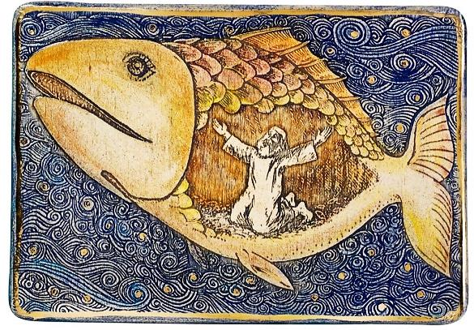

“For You cast me into the deep, into the heart of the seas, and the floods surrounded me; all your billows and Your waves passed over me” (Jonah 2:3). Just a surface reading of Jonah chapter 2 quickly embeds us smack dab in the gut of that giant fish with Jonah! Jonah was dying, literally! He knew he deserved his fate as God was forcing him to face the consequences of his sinful choice to rebel and reject His holy command!
The sentiment expressed in Jonah 2:3 may be just the thing we need to recognize from time to time: God may be forcing us to face the consequences of our sins! We’ve been warned throughout Scripture that sin has a horrid price tag. Remember when Moses spoke to the children of Gad after they promised they would cross over the Jordan River to join the other tribes to overthrow the Canaanites to secure their new homeland? Moses said in Number 32:23, “But if you do not do so, then take note, you have sinned against the Lord; and be sure your sin will find you out!” Remember what happened to Adam and Eve? They were banished from God’s plush garden because they ate from the tree God had forbidden them to eat from. Eve was told her conception and child-birth was going to be quite painful and oh yea, they were going to die! Sin can have an immediate earthly consequence or it may wait a while (maybe as long as Judgment Day) to reap it’s destructive course. For example, the sin of drunkenness may cause one to foolishly decide to drive drunk and cause a fatal accident or it may wait years down the road and promote a disease known as cirrhosis of the liver or it may wait till Jesus reads a death sentence from His word at Judgment (1 Corinthians 6:9-10).
One day, in some way, the consequences of our sin will come to a head and then, we’ll suffer. Christian, if you find yourself in a scenario like Jonah’s, repent and pray God fervently like Jonah is doing! Then, strive each day against the sin that so easily ensnares the soul! Don’t be cast permanently into the deep... arise to the surface! Serve King Jesus.

