Once upon a time, a king had a great highway built for the people who lived in his kingdom. After it was completed, but before it was opened to the public, the king decided to have a contest.
He invited as many of his subjects as desired to participate. The challenge was to see who could travel the highway the best, and the winner was to receive a box of gold.
On the day of the contest, all the people came. Some of them had fine chariots; some had fine clothing and fancy food to make the trip a luxurious journey.
Some wore their sturdiest shoes and ran along the highway on their feet to show their skill. All day they traveled the highway, and each one, when he arrived at the end, complained to the king about a large pile of rocks and debris that had been left almost blocking the road at one point, and that got in their way and hindered their travel.
At the end of the day, a lone traveler crossed the finish line warily and walked over to the king. He was tired and dirty, but he addressed the king with great respect and handed him a small chest of gold. He said, "I stopped along the way to clear a pile of rocks and debris that was blocking the road. This chest of gold was under it all. Please have it returned to its rightful owner."
The king replied, "You are the rightful owner."
"Oh no," said the traveler, "This is not mine. I've never known such money."
"Oh yes," said the king, "You've earned this gold, for you won my contest. He who travels the road best is he who makes the road better for those who will follow."
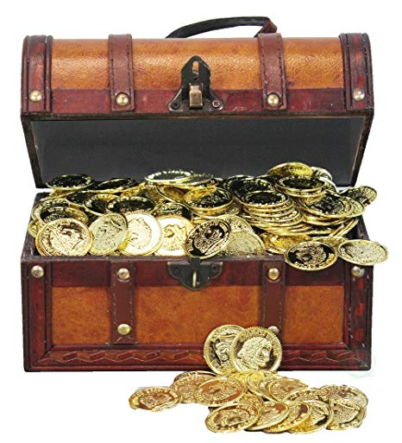

“And let us not grow weary while doing good, for in due season we shall reap if we do not lose heart. Therefore, as we have opportunity, let us do good to all, especially to those who are of the household of faith.” Galatians 6:9-10

