Would Jesus Have “Shot Dice” At The Parish Center Last Night?
Ken Sils – from the Caroline Street Communicator bulletin; 3/5/1995

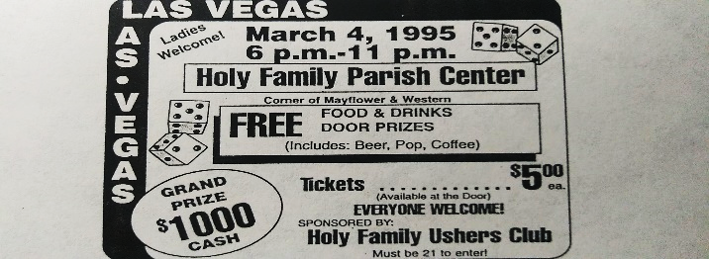

A decade ago, comedian Ray Stevens sang a parody titled something like, “Would Jesus wear a Rolex on the television screen tonight?” The message in his song was clear: the simple religion of Jesus in the Bible is diametrically opposed to the religion of “send in your seed-faith money to those filthy rich TV preachers.” Yet today, there are still millions around the country who continue to support preachers and their religious groups who, “by covetousness, they will exploit you with deceptive words (2 Peter 2:3)… alluring you through the lusts of the flesh, through licentiousness… ,” (2 Peter 2:18).
The advertisement at the top of the page, which I clipped out of last week’s Pennysaver, exemplifies the extent some religious groups will go to fill up their already fattened wallets. This group claims to be the “Holy Family Club,” but they could not be further from it. Consider some of their alluring elements:
1) To get you to participate with their “Holy Family,” they’re offering FREE BEER! “Come and get it…, free food, free fun and the best, free beer!” Can you imagine Paul approaching the sinners in Corinth thinking, “I know I’ll get them to come if I offer them free wine!” Absolutely not! Paul preached that drunkenness is a work of the flesh and will cause men to lose their souls (1 Corinthians 6:9-10). However, many modern-day churches groups like this one continue to prove that Peter knew what he was talking about when he said that people would be allured to corruption through sinful lusts. No doubt, they allured many sinners with all that: free beer!
2) To get you to revel with their “Holy Family,” they offered a “Las Vegas” night! Las Vegas has become known in many circles as America’s modern-day Sodom and Gomorrah. Just about every form of wickedness known to man is there, the gambling capital of the world. Millions have left their fortunes and souls in that sin-drenched city. In the name of Jesus, this church group wanted you to come over and “shoot dice and drink beer” with them last night, just like they do it in Las Vegas! Do you think they made any time for Bible study within their 5 hour “Las Vegas style” worship service? The question answers itself, doesn’t it?
3) To tempt your taste buds, they were inviting only “the 21 and over crowd” to come. Obviously, this “Holy Family” has no children, just adults who enjoy “adult things;” possibly such things as: adult drinks, adult games, adult movies and adult toys! Of course, ladies are welcome for what “Las Vegas Night” would be complete without lots of ladies? This “Holy Family Club” must be a very “grown-up” group! There was no room for children last night at the “Holy Family Parish Center;” especially no room for true children of God!
4) To entice your desires, they were offering a $1000 grand prize! Paul said to the Corinthians, “Do you not know that those who run in a race all run, but one receives the prize? Run in such a way that you may obtain it” (1 Corinthians 9:24). No doubt, many were running last night with all their might: filling up their mugs, spending bucks on BINGO, buying raffle tickets and catering to all types of carnalities in the hopes of winning: sordid gain!
It is not surprising to me why so many are fed up with “men’s religion about Jesus.” For decades, false teachers have employed every carnal method imaginable to extract ill-gotten gain from supposedly “holy people!” People are sick of Jesus being presented in this fashion and some are searching for the real Jesus of the Bible. If you are one of those people, seeking the real Jesus, the Savior who exacts true holiness and righteousness from men, let us study the Bible together!

