Worship Or Playing Church?
Dee Bowman
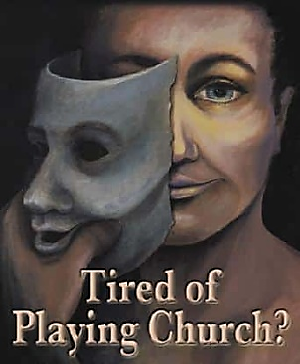
What an exalted privilege it is to worship God – to know who He is, to understand what He expects, to be confident that our heart-felt and humble devotion, our reverence and veneration, come before His majestic presence as an honor to Him. It’s almost too wonderful to contemplate.
I fear that far too many people are not as impressed with this great privilege as they ought to be. That fact is often shown by the inconsistency with which some participate in the worship services. They only come when it’s convenient to do so, and then only for as little time as they feel they can spare. I fear, too, that with some, participation is little more than a ceremonial observance, a scant observance devoid of any heart-felt spiritual commitment. Somehow they have decided that their mere presence is all that is necessary for acceptable worship.
There is great benefit to be derived from the public worship. But there is a danger, too – a danger that ritualism will replace sincere, heart-felt worship. A danger that the mere observance of the various ordinances is all that is due Him. In Ecclesiastes five, the wise man says, “Keep thy foot when thou goest to the house of God. And be more ready to hear than to give the sacrifice of fools; for they consider not that they do evil.” The meaning is clear: to lack the involvement of the heart when we come to worship is sin. (continued)

