Who Is A Christian? (Part #6)
Kenneth D. Sils

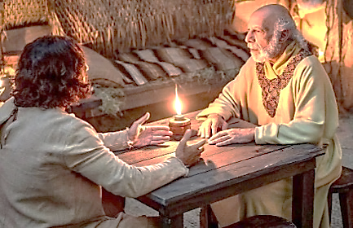

This lesson is our six and final lesson dealing with the topic, “Who is a Christian?” This study began discussing our need to “walk in newness of life” through the process Jesus instituted known as being “born again.” Other lessons spoke about the God-given name Christian, the spiritual food referred to as the bread of life which is the Word of God, the need for Christians to grow in the knowledge of God’s message and the importance of being properly clothed to protect ourselves and others from lusting.
I’ll close the study by considering the importance of a Christian to reflect the character of God in their everyday lives. One of the greatest speeches of history is known as the Sermon On The Mount, recorded in Matthew 5-7. Jesus began this all-inspiring lesson by telling the world what type of character or attitude we need to be pleasing to God. Jesus said in Matthew 5:3-10, “Blessed are the poor in spirit… those who mourn… those who hunger and thirst for righteousness… the pure in heart, the meek, merciful, peacemakers and persecuted.”
As you can see, Jesus told the world that His followers have responsibilities to mold their character in line with Divine character. A Christian cannot live just any old way he or she wants to. Being a real, true New Testament Christian demands that we leave the sinfulness, morality and ethics of this world behind while accepting and applying principles that Jesus left for us in the New Testament. Paul told the Christians in Rome this in Romans 12:1, “Present your bodies a living sacrifice, holy, acceptable to God which is your reasonable service. And do not be conformed to this world, but be transformed by the renewing of your mind that you may prove what is that good and acceptable and perfect will of God.”
You can be a real, true New Testament Christian if you want to be. Would you like to learn more about true and undefiled religion, far removed from the denominational creeds and theologies of men? If you would like transcripts of these lessons, we can send them to you or you can go to westmobilechurch.com to read, study or print off these lessons. If you would like the study these issues in a personal Bible study, I’d be happy to arrange a study at your convenience!

