Who Is A Christian? (Part #4)
Kenneth D. Sils

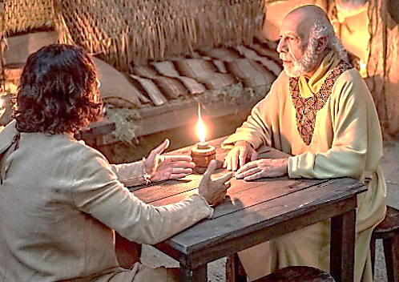

This is the fourth of six articles which is discussing the topic, “Who is a Christian?’ The first article taught us about the necessity from the Scriptures for men to walk in a “newness of life” through the Biblical process known as “the re-birth.” Then I discussed “the name” which God has given those who choose this spiritual rebirth; the name Christian. I also spoke of the spiritual food that God has given Christians to eat: the bread of life, the Word of God. All of these concepts are fundamental to the doctrine of the New Testament and continue to practiced by real Christians in our lifetime.
To continue to answer the question, “Who is a Christian?,” I’ll connect the purpose of God’s heavenly food for Christians as it enables one’s spiritual growth to adulthood or maturity. Growing spiritually is essential in a Christian’s life. The name “Christian” (which means Christ-like), demands that we mold our life in the same manner that Jesus lived on earth. This does not happen overnight. God will not send any one today some mysterious movement or vision which is designed to instantaneously make one feel as though I am an unflappable “Super-Christian.”
It is up to each Christian to learn and apply the truths of Scriptures in their lives. Peter’s last exhortation recorded for us in his second letter said, “Grow in the grace and knowledge of our Lord and Savior, Jesus Christ.” In Peter’s first letter, he said in chapter 2 and verse 2, “As newborn babes, desire the pure milk of the Word, that you may grow thereby.” Newborn Christians need to learn the basics about sin, Christ’s church, how to worship and serve God, Gods’ design for marriage, how to raise children and a wide assortment of principles and truths given for everyday living!
The religion that Jesus has given man in the New Testament is very practical for life. Those who are born again need to study the milk of the Word so they can become spiritual men and women with application and experience. If you’ve been involved in some denominational religion and do not have a clue as to what God has said about these basic things, the West Mobile church of Christ would like to assist your search for truth. Let us know at your convenience.

