Who Is A Christian? (Part #3)
Kenneth D. Sils

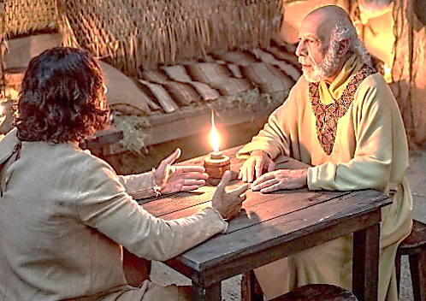

In our last two bulletins here at West Mobile, I brought two articles dealing with the topic, “Who is a Christian?” The first article demonstrated the necessity from Scripture for all to be “born again” in order to become a Christian. Paul told the Romans that they were buried in Christ through baptism, allowing them to walk in a new life. The second article mentioned the name which God gave for those who would believe in Christ. Believers were called “Christians;” nothing more, nothing less and we profess to be only this.
To continue to answer the question, “Who is a Christian,” we will now focus on the food prescribed by God for a Christian to consume. In John 6:27, Jesus said, “Do not labor for the food which perishes, but for the food which endures to everlasting life, which the Son of Man will give you.” Our emphasis should not be on “physical” food; all of living creation needs that type of food, and obviously, we do too to survive.
The food Jesus insists that we pursue with great vigor is “spiritual” food from God. This food does not come from the rituals, traditions, dogmas, creeds, conventions or doctrines created in men’s theology, but comes from the source of life Himself, Jesus Christ. When Jesus was confronted in the desert by the temptations of Satan in Matthew 4:4, He told Satan that, “Man shall not live by bread alone, but by every word that proceeds from the mouth of God.” Right there, Jesus defines the real, true spiritual bread that all of us need, the Word of God.
Sadly, there are many religious people who spend their lives in pursuit of earthly, temporal things when they let their Bibles sit on coffee tables, unopened and collecting dust. Then, they blame God for not giving them what they want and wonder why they can’t distinguish between truth and error. A real Christian escapes many of the pitfalls of life and seeks the home which God has promised by clinging to the Word He has given. Jesus said in Matthew 5:6, “Blessed are those who hunger and thirst for righteousness, for they shall be filled.”
Friend, how much do you know about the message of God given in the Bible? We would like to encourage you to begin feeding on the pure bread of life today, the Word of God.

