Who Is A Christian? (Part #1)
Kenneth D. Sils

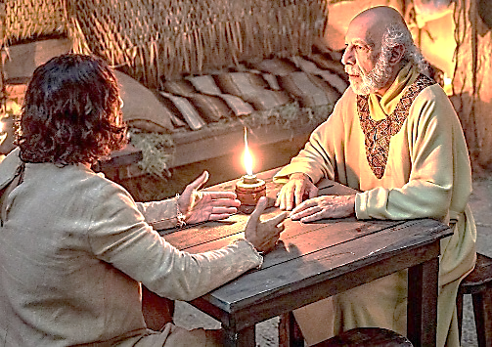

Have you ever asked yourself this all-important question, “Who is a Christian?” When this is asked, you’ll find almost as many different answers as the number of people asked. Yet, in the Bible, the question is answered factually and to the point. Today, and of the next five weeks, Lord willing, we will answer the question, “Who is a Christian?”
When Jesus began his ministry, He was confronted by one of the Pharisees named Nicodemus. He knew that Jesus was special as he declared in John 3:2, “Rabbi, we know that you are a teacher from God; for no one can do these signs that You do unless God is with him.” In response, Jesus said, “Most assuredly, I say to you, unless one is born again, he cannot see the kingdom of God.” Jesus was not mincing words with Nicodemus. He taught him firsthand the most important principle in life is being made right with God. Man must change; man must be re-born! To be a follower of Jesus, in order to be Christ-like or a Christian, one must be born again according to the declaration of Jesus in John 3.
Friend, do you know what it means to be “born again”? This question has been debated for centuries with all types of conflicting applications. The only safe place to find the real answer is to consult the holy Scriptures. Peter stated in 1 Peter 1:23, “Having been born again, not of corruptible seed, but incorruptible, through the Word of God which lives and abides forever.”
From God’s word, the apostle Paul reminded the Christians who lived in Rome what they did to be born again. In Romans 6:4, we read, “Therefore, we were buried with Him in baptism into death, that just as Christ was raised by the glory of the Father, even so we also walk in newness of life.” These people became Christians by being buried with Christ through baptism and were then raised to walk (live) in a new life. They were born again: born of water and the Spirit as ordered by Jesus in John 3:5 to Nicodemus. To be a Christian, one must be born again, just as the men and women did as recorded in the pages of the New Testament. If you desire to be reborn in this fashion, we would gladly assist you. Please continue to look for more articles on Who Is A Christian in upcoming bulletin articles – next week, Part #2!

