When The Tingle Becomes A Chill
Kenneth D. Sils
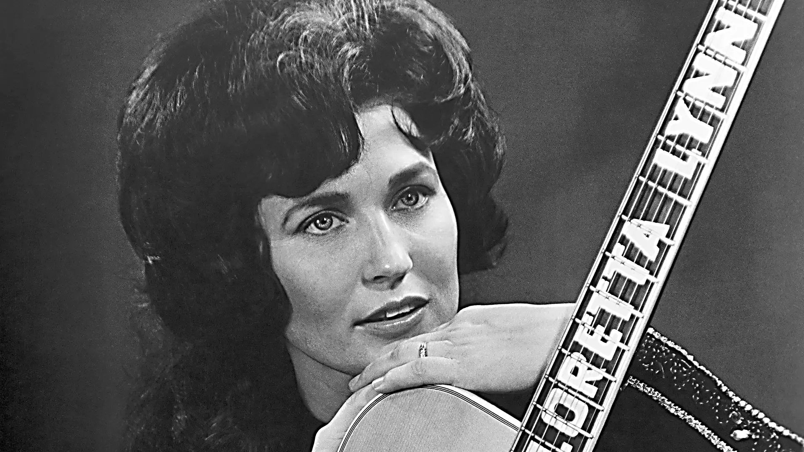

Many older country & western songs struck American heart chords. Not long ago, I heard a song from Loretta Lynn, a Hall Of Fame country artist, who sang a lot of songs about personal troubles in human relationships. That song is titled, When The Tingle Becomes A Chill. This song mourned the theme of a wife whose feelings of love for her husband were going colder with each passing day. She pined helplessly as she grappled with the flame she once was now barely a flicker. Where once his gentle touch brought romantic excitement, now it feels like a frozen lake! If you listen to Loretta’s song, you feel her heart breaking as she sinks into utter despair.
Brethren, there are a lot of things we can discuss about the relationship of love between a husband and wife, but I would like to take this concept into our relationship with our bridegroom, Jesus Christ! Our Savior knew this was happening with His bride in Ephesus and sent them a letter to address it. Jesus knew they were doing a lot of good things due to the relationship they had with Him, just like Loretta was doing with her husband…, Jesus knew: their love was running cold. He said to them in Revelation 2:4-5, “Nevertheless I have this against you, that you have left your first love. Remember therefore from where you have fallen; repent and do the first works…” Jesus saw, “their tingle of love turning into a chill” among His bride (the church) and will not accept any of their “reasons” to justify it! None, nada, zip… they’re just not going to work!
Brothers and sisters, can I ask you think about your “feelings” towards Jesus. Have you been “married” to Him so long spiritually that you know longer “feel” anything towards Him? Has your “spiritual marriage” lost a lot of its spirituality? Is attending a period of worship become a real challenge because you simply aren’t interested anymore? Is it like “pulling teeth” to get you to open-up a Bible, say a prayer or attend a Bible study? When the preacher/teacher asks you to open-up your home to hospitality or open-up your wallet to lay by in store properly, do you merely cast it aside because you’re too busy to mess with that stuff? Has it been ages since you’ve thought about inviting someone to church or discuss a Bible principle with you? The preaching used to be so exciting, the singing used to touch your soul, the Lord’s Supper – oh, how heart wrenching… but now, that “tingle” is long gone! “Let’s just get this over… I’ve got things to do!” Is this you?
Jesus gave us the prescription to save our marriages (physically and spiritually). Go back, remember and implement: the first works! Fellas, remember what you did and how you felt about that girl you dated? Ladies, remember what you did and how you felt about that fella who came a “callin’”? Start dating her again; start dating him again. Get out of that rut; do those things again that gave you those “warm” fuzzies towards your spouse. It may not work, but… it just might!
Spiritually, this prescription needs to begin today! Go back and remember what you were before you obeyed the gospel… really, really think about how you felt, what moved you to draw near to Jesus and then, obey His gospel! Try to remember that time you assembled where that simple prayer from a brother touched your soul, the words of those songs being sung stirred your emotions, the Lord’s Supper felt like a truck ran over you because you knew your sin drove Jesus to the cross and that preacher; well, he was preaching only to you and your conscious was being “wacked!” Repent, and do the first works… yep, Jesus has the answers to fix your heart and set you on a good course. That spiritual tingle can return! Let Jesus back in, brother or sister! And, when we get to heaven, that tingle will roar into eternal ecstasy. And, it will never grow old!

