When The Disciples Came Together To Break Bread
Kenneth D. Sils

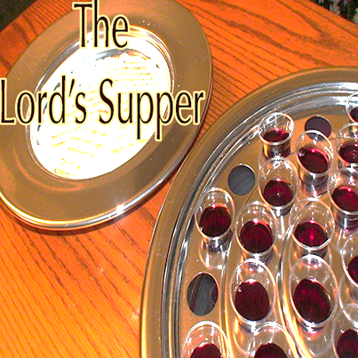

From city to city, Paul went throughout the ancient civilized world, preaching the gospel and establishing churches of Christ along the way. Finishing up his intense 3rd journey, He stopped at Troas to meet up with several of his traveling companions who had been working with him in the preaching of the gospel. Staying seven days, they waited to assemble with the local church at Troas on the 1st day of the week, Acts 20:6-7. These godly men knew that “the first day of the week” meant “a great day”; the established day when local churches across the world assembled to “break bread”. This “breaking of bread” was not in reference to eating a common meal together, but an essential aspect of fellowship as they “broke unleavened bread” in remembrance of the broken body of our Lord on the cross and then, “drinking the cup” in remembrance of His pure blood to forgive sin. The Lord’s Supper, this they shared in!
This passage, in a simplistic, yet vital example, reveals “the day” when Christians came together to eat the Lord’s Supper. If we add this, along with the verses commanding Christians to “lay by in store” for the saints (1 Corinthians 16:1-2), the first day of the week was clearly chosen by God as the day Christians would gather for public worship. As they did, so do we!
Millions of “believers” are gathering in church buildings today, celebrating an annual “man-made” religious holiday called Easter; a religious tradition that emerged no sooner than the middle of the 2nd century. Does it matter, people ask? The New Testament shows Christians gathering each 1st day of the week to share in the Lord’s Supper while millions today attempt to fellowship with God, relying on their man-made traditions which evolve over time.
Things like this matter! Place your feet in the sandals of 1st century Christians. They worshipped God according to the sound teachings of the New Testament. This is our call too!

