When Church Members Become Like “Visitors”
Wayne Duren – East Pointe bulletin
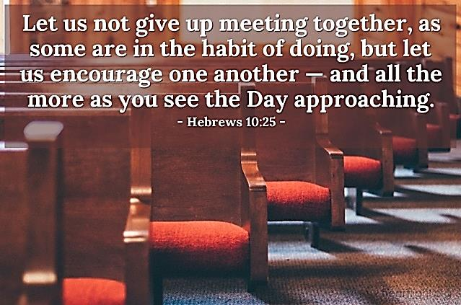 This is not only discouraging; it is tragic, relative to the numerous congregations of Christ’s church going through it! But... it was happening long before COVID was even on the horizon! So many congregations have dealt and/or are painfully dealing with it. Elders and caring members are praying for answers on how to deal with and encourage members who now attend worship services and classes no more than some of our visitors do! Some attend even less during a year than certain visitors; some less than four times a year! Many have stopped attending at all! Tragic!
Keep in mind that these type members often are parents with precious children involved. They not only put their eternal souls in peril, but their dear children are well, as they disobey the Holy Spirit’s demand in Hebrews 10:25 to not be guilty of, “forsaking the assembling of ourselves together”. Knowing God’s desire for brethren to assemble and worship, they dare to absent themselves and their family from such a wonderful opportunity. What are they doing that is more important for their souls?
Also, when these members, who have become more like “visitors”, first became New Testament Christians, were proper efforts made to make them aware of what God expects of every Christian, relative to obedience, worship, attendance, involvement, etc.? If not, why not? But, even if their respective congregations failed to afford these critical helps, they still should not have become like a “visitor” to their church family, which needs them so much! When one loves God, “with all their heart, soul, mind and strength” (Mark 12:30), we will do all that He demands of us, and do it gladly! That includes faithfully attending the worship! It is an inescapable truth that we will go to who, and what we really love! So, when a child of God has become more like a visitor than a worshipping, involved member, who and what do they love most?
Then, COVID did come! With it came the evil weaponry which many Christians have allowed Satan to use against them and their congregations to the point where, in some cases, the precious name “Christian” and all it entails, may have been reduced to an “in name only” status! Some are now realizing it! Thankfully, some of our preachers are now speaking out against how we’ve allowed COVID issues to take the Lord’s church to a weakened existence! Satan was/is the “driver” of that evil vehicle that many chose to jump into, as overreaction was at a premium! While godly precautions are imperative, some with unfaithful fear shut down things unnecessarily while some congregations wisely didn’t and are not spiritually rewarded as a result! Some “temporarily” suspended certain aspects of worship, etc., but are still in “limbo” when getting back to “normal” should have already happened, as most of us have been doing much as we wanted in other areas of life for a while now! But, relative to services of the church, and knowing that God has always wanted His children to gather in worshipping Him whenever they are able, many are still blaming COVID for the absence of members, and for not doing what the body of Christ could and should be doing!
Brother Adam Faughn wrote an article entitled, “Church Leaders, Quit Blaming It All On COVID”, a fair and balanced article on the church’s COVID problems! Some elders are not realizing mistakes made, and are seeking to reverse this thing wherein possible, knowing that some weak members are gone for good and some others have “become like visitors!” Let us all, like David, be, “glad when they said unto me, ‘Let us go into the house of the Lord.’” (Psalm 122:1) Let’s do our best!

