What’s The Big Deal About A Songbook?
Kenneth D. Sils

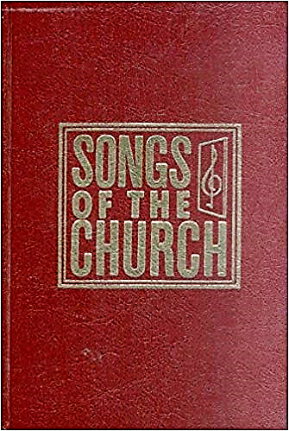

That seems to be a rhetorical question: a songbook is a songbook is a songbook. We are so blessed in America! Any local church can contact a variety of bookstores throughout the country or get on “the net” and find a plethora of songbooks for the singing of “psalms, hymns and spiritual songs, Ephesians 5:19”, including the songbook we use and is pictured here. An, with the use of “media mail”, they can mailed right to our doors at a fairly small cost!
Last week, I ran across a plea from the preacher with the Kings Cross church of Christ, requesting 30 copies from any person or congregation who no longer needs them. Well, what is the big deal about that? This congregation of God’s people is “across the pond”, in London, England! They need this particular songbook because one of their members is blind and has a copy of Songs Of The Church in braille. We sent them 22 copies of our songbook and made it clear to not concern themselves with any financial compensation. David Cambridge wanted me to share their sincere appreciation for the love and good will we’ve shared with them. Oh yes, we are a brotherhood, 1 Peter 5:9. It is a good (and Scriptural) thing to assist our brethren who reach out with genuine needs like this, even if it’s “across the pond”. Well done, brethren!

