What It Means To Give Blood
Author Unknown

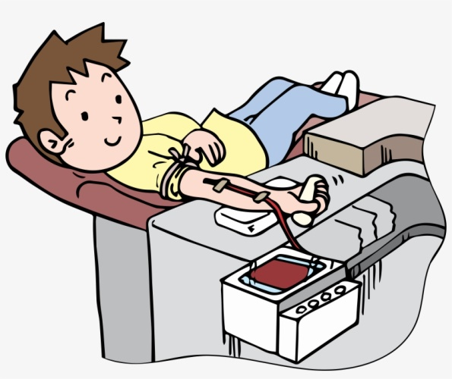

Many years ago, when I worked as a volunteer at Stanford Hospital, I got to know a little girl named Liz who was suffering from a rare and serious disease. Her only chance of recovery appeared to be a blood transfusion from her five year old brother, who had miraculously survived the same disease, and had developed the antibodies needed to combat the illness. The doctor explained the situation to her little brother, and asked the boy if he would be willing to give his blood to his sister. I saw him hesitate for only a moment before taking a deep breath and saying, “Yes, I’ll do it if it will save Liz.”
As the transfusion progressed, he lay in bed next to his sister and smiled, as we all did, seeing the color returning to her cheeks. Then his face grew pale and his smile faded. He looked up at the doctor and asked with a trembling voice, “Will I start to die right away?” Being young, the boy had misunderstood the doctor. He thought he was going to have to give his sister all of his blood.
This wonderful little boy illustrates the power of sacrificial love. His sister’s life meant more to him than his own. This was the mindset of Jesus for each of us. His blood, all of it, flowed forth from His body so man could go to heaven. His blood provides sinful men a blood transfusion, putting the spiritual color back in our cheeks. You cannot help but love this little boy. How can we not but love Jesus, who died so we may live forever?

