What Is The Difference?
Irvin Lee / Auburn Beacon – circa 1960’s

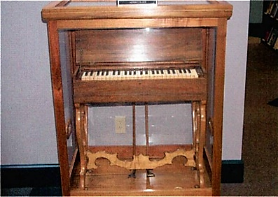
An instrument of music was introduced into the worship at Midway, Kentucky about 1858. This innovation moved slowly among churches in the North and finally came to the South about 1900. Of course, the church support of the Missionary Society and other central collecting and disbursing organizations came with the instrument. The intra-church organizations also came along about the same time, as well as church sponsored entertainment and fraternization with the Protestant denominations who taught that one is saved at the point of faith before obedience.

If a stranger had come to some little town in the early part of this century and had inquired as to the location of the meeting place of the church, some local man might have asked, "Which one?" The stranger might then have asked, "What is the difference?" He would have been told that one used instruments of music and the other did not. Division usually came when the instrument was added. Actually, the social gospel and the church support of man-made institutions also marked the difference, but these facts were not so conspicuous to the neighbors at first. Even the churches themselves gave almost nothing but lip service to the societies with an occasional small token gift of money.

The greatest difference of all was not seen or generally realized. The real difference was in the attitude toward the Bible. Those who brought in the innovations would say that the Bible does not say that we should not have these things. To them the silence of the scriptures meant liberty to add samples of human wisdom. Those who did not approve of the instrument and the societies pointed out that these things were without New Testament authority. They were not commanded, implied or taught by approved example. To them it was a sin to go beyond that which was written (2 John 9; Revelation 22:18-19; 1 Peter 4:11; 2 Peter 1:3). - on back

