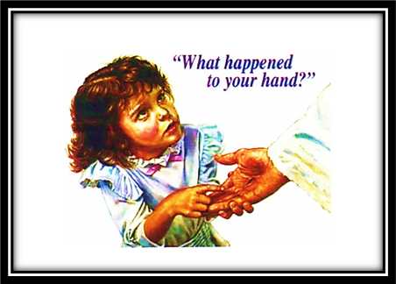
Have you seen this picture before? This picture – its awe striking! The 1st time I saw it, I was immobilized for a few moments. This sweet young girl appears to be both befuddled and yet, intensely concerned for the One who suffered this gaping, deep wound in His hand. Her look is preciously “haunting,” isn’t it?
Sometimes, I feel this way about the great plan that this picture is forcing me to consider. It is almost too much for me to properly discern the depth of Jesus’ loving sacrifice for me, for you… for all of us! We are sinful, undeserving creatures who have, far too often, turned our collective backs on God and His authoritative commandments. And each of us, despite our ignorance or even willful rejection and malice against God’s teachings, know that we are personally guilty for nailing the Messiah of Israel to His cross. My sin forced that nail print! His agonizing death was my only hope to yield the escape hatch from the fires of Hell prepared for the devil, his angels and sinners across the globe. As that famous song rang out its chorus, “He could have called 10,000 angels, but He died alone for you and me!” Yes, Jesus did! The most brutal of all deaths, the eternal God and Savior of men faced… willingly, voluntarily, in all purity... knowing His precious blood would flow from that “nail print” and all the other horrid wounds inflicted upon Him at His crucifixion to cleanse me from my sinful self!
If only more people would be like this young girl in the picture. If only more would express a genuine curiosity as to why Jesus had gaping holes in His hands and feet. Paul declared in Romans 5:8, “But God demonstrated His own love toward us, in that while we were still sinners, Christ died for us.” Yes, Jesus did. He died for me… and you too! Millions have been thinking about the death, burial and resurrection this weekend. Please, do more than think about it! Allow that nail print to harden your resolve to serve King Jesus more and more with each passing day! - Ken

