What Does It Say About the Church?
Mike Davis / Orleans church e-bulletin

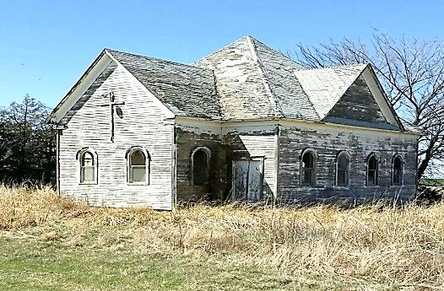

Some dear friends recently sent me a picture of a meeting house I immediately recognized. No one had met for worship in that old building for more than forty years by the time that picture was taken! It’s gone now -- just a pile of rubble remains. I remember several years ago, dad stopped at a house near that old building, and spoke with the woman on the porch. He told me later that he asked her to seriously consider worshipping with a faithful group meeting just about five miles away from that small town. Her answer impressed dad as she said, “You know, I’ve been thinking I should. This church doesn’t do much anymore!” Really?
In my collection of meeting houses of the Lord’s church, I’ve several that are no longer hosting faithful brethren for worship. I’ve been to worship in most of them; but “something happened” and they’ve since “closed the building.” Oh, I grant many areas have no one close; for a variety of valid reasons, no one lives around there, and they’ve moved on to where the church is stronger; at least “by number.” Still, in some sad way, the empty building says, “The church doesn’t meet here. They lost interest in staying busy.”
Some years ago, a sister in Christ shared a true story with me. She and her husband were on a vacation trip, but had planned to worship in a certain town. They had inquired, and yes, someone informed them the church of Christ was located on such-and-such street. (Of course they meant the building - read on.) Not wanting to be late, the couple drove to the building on Saturday night and noticed a poster on the door. Thinking it would inform of the times of assembling, she got out of the car and went to the door and read, “This church doesn’t meet here anymore.” (Obviously, the building isn’t the church - so the “church” wasn’t in that town!)
We could discuss such realities all day, but let’s get a little closer to the point: What does an EMPTY SEAT say about the church? Most of us “older ones” have been around enough to remember full meeting houses for every service. We can often name the families that sat in those now empty seats. What happened? Oh I know young people grow up and leave home. Been there, done that, got the t-shirt times two! Granted, things change and some just have to move. Been there, done that also! But isn’t it strange that in most cases THE COMMUNITY STILL EXISTS - the meeting house is still there - but there’s just so many more empty seats than there used to be. Why? What’s that say about the church?
True, it doesn’t take a hundred or more to make a fine assembling! The scriptures indicate several occasions of only a few assembled for worship. (Be careful about using Matthew 18:20 to approve small assemblies of worship. That passage isn’t talking about worship!) Still, if the Lord’s church has been established in a place for a lengthy time, and the surrounding community continues to have growth of citizens, it would seem the Lord’s church should be growing as well… IF IT IS DOING THE WORK THE LORD GAVE HER TO DO!
Notice Matthew 28:19-20 and tell me where those with the gospel were to go to teach, baptize and teach those they had baptized to do the same? Examine Mark 16:15-16 and answer the same question. Where does this “world” start? With rural communities (very similar to where we are!) most within that community are “continued generation citizens” meaning very few families ever lived anywhere else but here! Are they Christians? Has the Lord’s church reached out to teach them, encourage them, and prove the TRUTH to them? Think about what THAT says about the church!

