Was The Apostle Peter A Pope?
David J. Riggs / Interactive Bible website
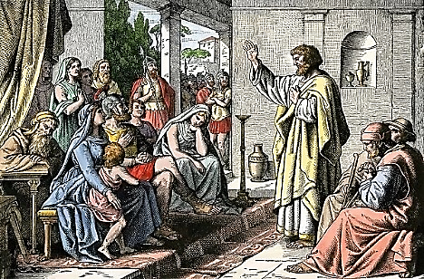
In the books of men, the following titles are commonly used with reference to a man: "Pope," "Holy Father," "Vicar of Christ," "Sovereign Pontiff." All of these are titles that rightly belong only to the Lord Jesus Christ and to God the Father. There is not a single instance in the Scriptures where any of the above titles are applied to a man. The term, "Holy Father" is used only once in the entire Bible, and it is used by Jesus in addressing God the Father. (John 17:11)
Among the above titles is the bold assertion that the Pope is the "Vicar of Christ." A "vicar" is "One serving as a substitute or agent; one authorized to perform the functions of another in higher office." (Webster). When one searches the Bible from cover to cover, he finds only one passage which gives an indication of a vicar of Christ or God. It is 2 Thessalonians 2:3-4. It is worded as follows, "Let no one deceive you in any way, for the day of the Lord will not come unless the apostasy comes first, and the man of sin is revealed, the son of perdition, who opposes and is exalted above all that is called God, or that is worshiped, so that he sits in the temple of God and gives himself out as if he were God."
Some religionists today advocate that man is saved by faith only. However, there is only one passage in the entire Bible that has the words "faith" and "only" together and it says, "not by faith only" (James 2:24). The Catholics today speak of the Pope as Vicar, taking the place of God (Christ Himself is God, Matthew 1:23; John 1:1), yet there is only one passage in the entire Bible which speaks of a man doing such and it calls him "the man of sin."
James Cardinal Gibbons, a Catholic Archbishop said, "Jesus our Lord, founded but one Church, which He was pleased to build on Peter. Therefore, any church that does not recognize Peter as its foundation stone is not the Church of Christ, and therefore cannot stand, for it is not the work of God." The Faith of Our Fathers, p. 82. The apostle Paul said, "For other foundation no one can lay, but that which has been laid, which is Christ Jesus" (1 Corinthians 3:11). There is no other foundation but Christ! Therefore, any church which does not recognize Christ alone as the foundation stone cannot be the church of Christ. (continued on the back)

