Was Elvis A Christian?
Zeke Flores – FB post

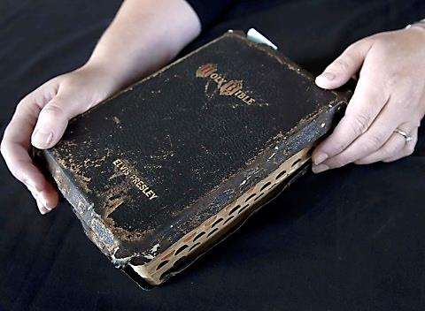

Several years ago, a Bible given to Elvis Presley by his uncle in 1957 sold at an auction in the U.K. for $95,000. It was Elvis' personal possession until his death in 1977 and contained his own handwritten notes, thoughts, annotations, and even some underlining of various verses. Interestingly, one of the underlined verses was Matthew 16:26, “For what is a man profited, if he shall gain the whole world, and lose his own soul?” (Christian Post, articles dated Sept 9 & 10, 2012)
It’s hard to conceive that the “King of Rock & Roll” held any kind of personal faith, considering the lavish and hedonistic lifestyle he lived, the massive quantities of drugs he ingested, and his general ambivalence toward morality and religion. It’s said that he stopped attending church in his teens and it never seemed to have any real impact on his life. And yet, he recorded numerous religious songs, many of which were hugely popular.
And then, there’s his Bible, scribbled in with personal thoughts, underlined, and obviously worn with use. Even today, especially among those who were impacted by his music, he remains a sort of paragon of virtue in spite of his ungodly way of life.
Often, that’s the way of many men and women: we’re tangled messes of contradictions. We believe and even advocate for what we believe is moral and decent while compromising those beliefs in the name of convenience. We eschew the use of profanity, shun sexual immorality, and plead for non-violence, yet immerse ourselves in entertainment in which those activities abound. We are convicted that the gospel is God’s lifeline to lost man and recognize a pattern, a plan, in it by which a man can be saved if he obeys it, but never mention that plan to the people around us.
It’s true that as long as we have free will, we will be constantly bombarded with competing affections and morals. But, is there a way we can be more obviously consistent? Of course, there is, and the answer is shockingly simple. I don’t mean it’s easy to do, I mean it’s easy to understand.
The key to consistent righteous behavior is in keeping a frame of mind which will guide us in how we show ourselves to be genuine people of character and religious integrity. It’s referred to as the “renewing of your mind” (Romans 12:1-2, Ephesians 4:17-24, Colossians 3:2-5) and is the instigator behind all our proceeding actions. But it’s not all warm and fuzzy thoughts. Those intentions must be followed up by what we do and when we slip up - and we will - it’s important to learn from the mistake and vow never to let it entangle us again. That means being willing to make some radical changes in life if your lifestyle is to match your declaration.
As for Elvis, I’ve got an idea about whether or not he’s accepted by God but his fate is in the hands of that God who knows him better than me. As for me, life is never as clean-cut as I would like it to be. It’s full of contradictory behavior and messes, most of which I make myself. But it doesn’t have to be. We CAN live in a way that no one will ever have to ask, “Was he a Christian?”

“Therefore bear fruit in keeping with repentance” (Matthew 3:8)

