Three Hours Of Darkness At The Cross
Heath Rogers / Chester church bulletin

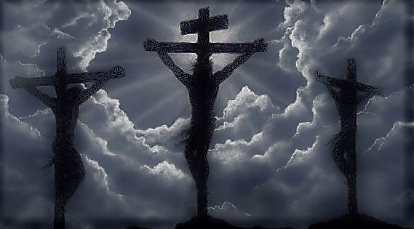
There were three hours of darkness over the land when our Lord was dying on the cross. This event is recorded by Matthew (Matthew 27:45), Mark (Mark 15:33) and Luke (Luke 23:44-45). What is the significance of this darkness?
We know the darkness was a miraculous event. It was not what we recognize as a solar eclipse. Eclipses only last a few minutes – this darkness lasted three hours. Solar eclipses only happen during the New Moon phase. Passover always take place during the Full Moon, and Jesus was crucified at Passover. Matthew and Mark say the darkness was “over the whole land” while Luke says it was “over all the earth.” There are questions regarding the extent of this darkness. Was it just in Jerusalem, limited to the land of Judea, or witnessed across the Roman Empire? Secular records exist of the darkening of the sun at midday during the reign of Tiberius. When writing to his pagan adversaries, Tertullian spoke of this darkness, “which wonder is related in your own annals and is preserved in your archives to this day.”
The night before His crucifixion, Jesus rebuked the mob that came to arrest Him in the garden of Gethsemene by saying, “Have you come out, as against a robber, with swords and clubs? When I was with you daily in the temple, you did not try to seize Me. But this is your hour, and the power of darkness” (Luke 22:52-53). The Lord’s enemies moved against Him in darkness because their deeds were evil and because they feared the multitudes. How fitting that their deed would usher in darkness, serving as a sign to them and all the Jews that a great injustice was being done.
The Scriptures use the darkening of the sun of God’s judgment. “’And it shall come to pass in that day,’ says the Lord God, ‘That I will make the sun go down at noon, and I will darken the earth in broad daylight’” (Amos 8:9; see also Zephaniah 1:14-18; Matthew 24:29-30; Revelation 6:12-17). Jesus was offering Himself as the sacrifice for the sins of the mankind. He was paying the penalty for sin, a penalty which included darkness (Matthew 8:12, 22:13, 25:30). How fitting for the pouring out of God’s wrath upon sin be shrouded in immense darkness.
It is interesting that our Lord’s death was accomplished by a darkening of the midday sun. His birth was announced with the lighting of the night sky (Luke 2:8-14). The angelic choir lit up the darkness with radiant glory to announce His birth, while nature itself recoiled from the horror of His death. This darkening of the midday sun is just one of many things that caused the centurion to conclude, “Truly this was the Son of God!” (Matthew 27:54) These things are written that we may likewise believe.

