Thoughts And Prayers
Matthew Bassford / FB post
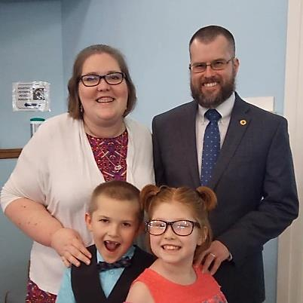
People in our society say lots of dumb things. Surely among the most foolish, though, are the denials of the power of prayer. This usually comes up after mass shootings, when conservatives send “thoughts and prayers” on behalf of the victims’ families. In reply, progressives sneer that thoughts and prayers aren't enough. What we really need is action on gun control!
There are a couple of problems here. The first is that action from the government is in no way comparable to prayer. God is all-wise and all-powerful. The government, well. . . those who put their trust in princes would be well served to study some history and learn how trusting princes works out.
Second, I suspect that people who show contempt for prayer typically have never prayed and have never been prayed for. Since I was diagnosed with ALS last July, I have been the beneficiary of countless thousands of prayers, so I suppose that I am in a better position than most to testify to their effectiveness.
Simply put, my experience is this: without those prayers, I cannot even imagine how bad my life would be. No, they haven't cured my disease, but I didn't really expect them to (though I certainly would have been thankful if they had!) It is appointed to man once to die, and the promise of God is not the removal of affliction but comfort through affliction.
The latter I have indeed experienced, in spades. In fact, I usually find myself in the strange position of being much more at peace with my decline and death than the people I talk to are. This should not be! After all, I'm the one whose legs are so bad that I can barely walk and whose hands are so bad that I can't type or button a shirt. They're healthy, but they're broken up, and I'm not.
This is not the result of my strength of will or my faith. I learned the limits of my willpower last year when I was suicidally depressed. Concerning faith, I feel that mine is not the equal of the faith of many who are praying for me.
Nor, I think, does the answer even lie in the antidepressants that I'm taking. I've been saying for a while now that my experience with them has been amazing, far better than that of anyone else I know. I am baffled.
It occurs to me, though, that in my perplexity I have been overlooking a confounding variable. About the same time that I started taking antidepressants, I also went public about my illness and made the prayer lists of churches all over the world, and the prayers have been doing the real work. Antidepressants are a blessing, but prayer is a much greater blessing.
Because of those prayers, I have been able to continue my work. I have been able to encourage and inspire others, more powerfully than I have ever done before. Even as my body continually reminds me of the progression of my disease, I am filled with joy and hope.
Consequently, whenever somebody tells me that they have been praying for me, I thank them fervently and encourage them fervently to continue. In fact, I think that sometimes people are taken aback by the warmth of my response. I'm dead serious, though! I am in constant need of all the prayers that anyone is willing to offer.
Pray, then, and do not lose heart. Pray for me, and pray for all the other godly goals that are on your heart. Pray, and keep praying. You will find a blessing that all those who mock thoughts and prayers will never experience.

(Matthew is a dedicated and well respected preacher of God’s word who has been upfront with his health battles on FB for some time. His health is rapidly declining. PLEASE, pray for Matthew! – kds)

