This Is The Gate Of Heaven!
Kenneth D. Sils

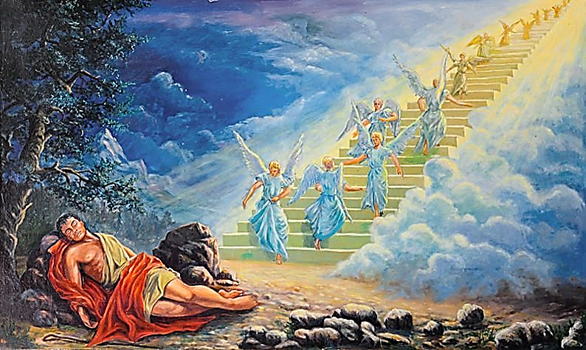

“And he was afraid and said, ‘How awesome is this place! This is none other than the house of God, and this is the gate of heaven.’” (Genesis 28:17). When you read this amazing story in Genesis, you kind of feel for Jacob, but know that his dire circumstances were from his own devices. He faked, through his mother’s prodding, to be his brother Esau in order to deceive Isaac into granting him the “great” blessing that God offered his father and grandfather. And now, he is on the run, fearing for his life... alone in the dark... his pillow, a stone!
God comes to the rescue with this amazing vision! Jacob sees a ladder extending to heaven with God’s angels gliding up and down upon it! There are a few things upon awaking Jacob recognizes immediate: 1) God was there with him in this awesome place and 2) this place was the gate to heaven! Wow, wouldn’t you like to see a vision of a “staircase to heaven”? I know I would!
Jacob named this place Bethel, meaning: the house of God. And, this has New Testament implications. A similar expression was used by Jesus as Nathanael confessed his faith in Jesus as the Christ in John 1:51, “Most assuredly, I say to you, hereafter you shall see heaven open, and the angels of God ascending and descending upon the Son of Man.” Jesus is our real, true ladder! Jesus is the ladder to heaven! There is only one way to get to heaven from here and that is through Jesus Christ. Paul told Timothy in 1 Timothy 2:5, “For there is one God (He is in heaven) and one Mediator between God and men, the Man Jesus Christ.”
If we make it to heaven, it will be through Jesus and our willingness to get to “the gate”. We need this awesome spiritual place where Jesus is: the house of God. Paul said this to Timothy in 1 Timothy 3:15, “... I write so that you may know how you ought to conduct yourself IN the house of God, which IS the church of the living God, the pillar and ground of the truth.” Present yourself to Jesus in full faith, enter the church of Christ on earth and begin your ascent to God’s wonderful throne. What a picture! This is the life and walk of God’s children - Christians!

