The Power Of Silence
Kenneth D. Sils – continued from the front

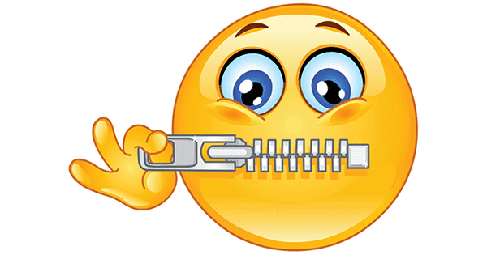

What they just spewed towards Moses could not have been improved on by the devil himself! It was God (not Moses), who through His mighty hand, brought them out of Egypt! God didn’t bring them out of there to die in that wilderness, but to free them, make a covenant with them and elevate them to be His special nation among men to serve Him, not those pagan slave masters! They simply could not have been more wrong in what they had just said!
Why did they say what they said? Fear, panic, terror… expressed in emotional outburst! This is what fear will do to us. Opening our mouth when our emotions are “high-pitch” is often the worst thing we can do at that moment! In the midst of emotional explosions, we can say some really foolish things and do far more damage than the situation ever called for!
Notice how Moses handled this in Exodus 14:13-14, “Do not be afraid. Stand still, and see the salvation of the Lord, which He will accomplish for you today. For the Egyptians whom you see today, you shall see again no more forever. The Lord will fight for you, and you shall hold your peace.” In plain old 2020 verbiage, Moses told the people to shut up! Be quiet!
As a parent, we’ve probably said such things to our children when they acted or spoke foolishly -- be quiet and stand still! They needed that strong hand, right then! Israel complied and watched the salvation of the Lord part the Red Sea right before their eyes; they walked through those divided sea walls and watched the chariots of Egypt destroyed. The Lord worked “the impossible”. Do you think upon reflection that 100’s of 1000’s wanted to “take back those words” they spewed in the grip of fear? You know they did!
So often, silence is golden! Silence offers us time: time to think, time to reflect, time to pray, time to open up a Bible, time to talk with a cherished friend, time to cool down, time to realize, “Nah, this isn’t the hill I want to die on.” Silence is golden! It can save a friendship, a marriage, a job or a reputation. Sometimes, it can save us on Facebook, Twitter, Snap-chat or any other social media craze that is everywhere in society today. There are times we should all hit that “backspace” key, over and over again! Yes, silence is golden.
Before I leave this message, let me throw a rising curve ball. The wise Preacher said this about “a time for every purpose under heaven” in Ecclesiastes 3:7, “A time to tear, and a time to sew; a time to keep silence, and a time to speak.” God didn’t create us to be marshmallows; there is definitely: a time to speak! God expects us to speak up and speak out, but, when we do: speak carefully, speak truthfully, speak with respect, recognizing that our Master, Jesus Christ is listening to everything coming out of our mouth. Remember what James said in James 1:19-20, “So then, my beloved brethren, let every man be swift to hear, slow to speak, slow to wrath; for the wrath of man does not produce the righteousness of God.”
I admit, sometimes I fail at these exhortations. I’m trying to do better! In the wake of all the social, political and religious unrest in our land, let’s all do better! Speak the truth in love, Ephesians 4:15. Be kind, longsuffering and compassionate in your words and deeds towards others. Remember the warning of Jesus in John 12:48, “He who rejects Me, and does not receive My words, has that which judges him – the word that I have spoken will judge Him in the last day.” Oh, yes may your words be slow and measured. Remember, there are many times in life that: silence is golden!

