The Paradox Of The Cross
Ken Weliever / The Preacher’s Word

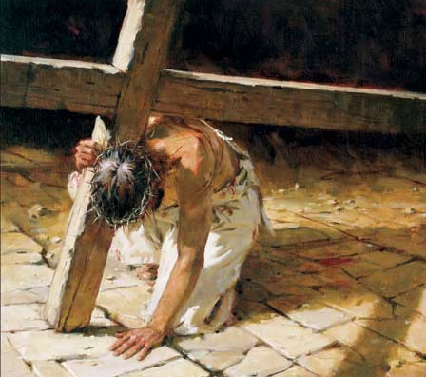

The crucifixion of Christ on the cross was one of the great paradoxes of all human history. By definition a paradox is “a statement or proposition that seems self-contradictory or absurd but in reality expresses a possible truth.” Jesus often spoke truths that contained a paradox.
Here are three examples: “Whoever finds his life will lose it, and whoever loses his life for my sake will find it” (Matthew 10:38). “For everyone who exalts himself will be humbled, and he who humbles himself will be exalted” (Luke 18:14). “Whoever wants to become great among you must be your servant” (Matthew 20:26).
These statements contradict the conventional wisdom of the world. In the same way so did Jesus’ death. It’s a paradox that is difficult for the world to comprehend. It was true in the first century. Paul spoke to this issue when he wrote to the Corinthians, “For the message of the cross is foolishness to those who are perishing, but to us who are being saved it is the power of God. For it is written: ‘I will destroy the wisdom of the wise, and bring to nothing the understanding of the prudent.’ Where is the wise? Where is the scribe? Where is the disputer of this age? Has not God made foolish the wisdom of this world? For since, in the wisdom of God, the world through wisdom did not know God, it pleased God through the foolishness of the message preached to save those who believe. For Jews request a sign, and Greeks seek after wisdom; but we preach Christ crucified, to the Jews a stumbling block and to the Greeks foolishness, but to those who are called, both Jews and Greeks, Christ the power of God and the wisdom of God. Because the foolishness of God is wiser than men, and the weakness of God is stronger than men.” (1 Corinthians 1:18-25)
John Clark used to say that a paradox was truth standing on his head! Consider what seemed so true on Friday was turned upside down on Sunday. On Friday, Jesus ministry came to a tragic end. He was forsaken. Wounded. Humiliated. Killed. He failed to establish His Kingdom. Darkness prevailed.
Or, so it seemed!!! Yet, Sunday told a different story!!! The cross was necessary to accomplish the will of God and His eternal purpose. Tragedy turned to triumph when Jesus arose from the dead. His failure became the consummate success story as the name of Jesus spread throughout the Roman Empire. Out of darkness, came eternal light!!! Instead of ending His ministry, the cross was the instrument to enhance, enlarge and extend it.
Jesus was forsaken that we might be forgiven. He was wounded that we might be healed. He was humiliated that we might be glorified with Him to sit in heavenly places. He was killed that we might live. The crucifixion was the cornerstone to the Kingdom’s coming and became its central message. Indeed he was sacrificed that we might be saved.
When you assemble this Sunday, consider the paradox of the cross. Remember why it happened. What it means. And how it can change your life. Both in time and for all eternity.

