The End Of The Road Is But A Bend In The Road

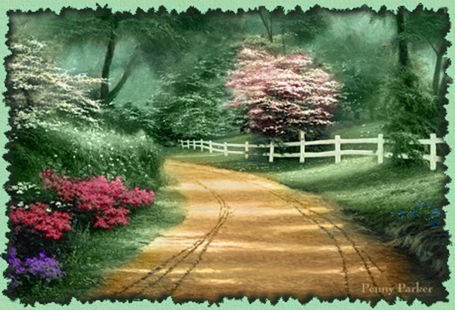

When we feel we have nothing left to give
And we are sure that the “song has ended” –
When our day seems over and the shadows fall
And the darkness of night has descended,
Where can we go to find the strength
To valiantly keep on trying,
Where can we find the hand that will dry
The tears that the heart is crying –
There’s but one place to go and that is of God.

And, dropping all pretense and pride,
We can pour out the problems without restraint
And gain strength with Him at our side –
And together we stand at life’s crossroads
And view what we think is the end,
But God has a much bigger vision
And He tells us IT’S ONLY A BEND –
For the road goes on and is smoother,
And the “pause in the song” is a “rest,”
And the part that’s unsung and unfinished
Is the sweetest and richest and best –
So rest and relax and grow stronger,
LET GO and LET GOD share your load,
Your work is not finished or ended,
You’ve just come to “A BEND IN THE ROAD” -Helen Steiner Rice

