The Booing Spectators
Bill Hall / Auburn Beacon
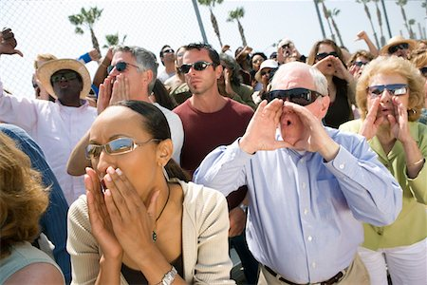
Have you ever noticed who does the booing at a ball game? It's not the players on the field. They make their own mistakes and they are not inclined to boo their fellow player when he makes his. They are pulling for one another, encouraging, helpful. They play as a team, win or lose as a team. It is the spectators who boo. So it is in every walk of life: it is the spectators who, as a rule, do the criticizing, not the participants.
Unfortunately, in every congregation, there are the spectators and the participants. The spectators never teach a Bible class, preach, lead singing or preside at the table; they really don't get that much involved in the worship itself. But more often than not, they are the very ones who are found criticizing the preacher or song leader or Bible class teacher. They are the ones who are so embarrassed and incensed when someone inadvertently commits an "error" in his efforts to lead the group. They come wanting to hear something that is interesting and that will make the time fly by. If they hear it, they "cheer"; if not, they "boo."
Not so with the true participants, those who are really involved in the Lord's work. They are the ones "cheering on" that "rookie" who is preaching his first sermon or leading his first song. When a brother attempts to teach his first Bible class, they are looking for ways to be helpful. They are sympathetic; they rejoice in the success of others; they mourn over the sorrows of others; they feel for the one who has failed, make allowances for him, encourage him to try again, and assure him that he will do better next time. They rejoice especially in the development of the young men and women in the Lord's work. They are just as nervous and excited when the young people make their first attempt at presiding at the table or teaching a class as they would be if it were their own children.
How many preachers have decided to move because of the booing spectators, right at the time when the participants were enjoying their greatest spiritual growth? How many elders have planned the work around the demands of the spectators rather than the needs of the participants?
Spectators need to become participants and find out what it's like out there "on the field." Participants need to keep on doing their best, ignoring the "boos" while looking to their all-seeing and understanding "Manager" for approval. All need to be preparing for judgment, where it will be the "doers of the word," not the critics, who will be saved. "Finally, all of you be of one mind, having compassion for one another; love as brothers, be tenderhearted, be courteous" (I Peter 3:8).
Christians, like ball players, make a sad mistake when they listen too closely to the "boo-birds."

