Straight Talk About Hell
Matthew Bassford – FB post

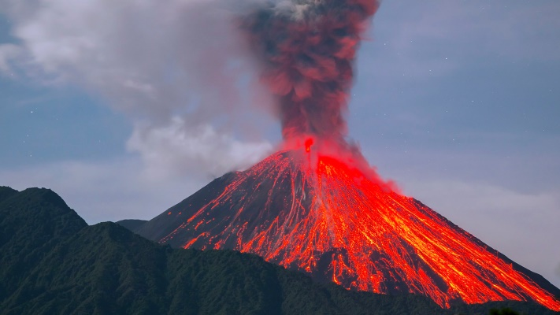
During our recent trip to Hawaii, my wife and I saw many amazing things. Of them all, though, the most amazing was the active volcano. Lauren saw that Kilauea had begun erupting again just before we left, so we decided that we wanted to visit the crater rim after dark, when it would be most visible.
We ended up on the rim about a mile away from the molten part. We could see steam hissing out of vents all over the caldera floor, one of which was stained a brilliant yellow by the sulfur coming out of it. After dark, we could see molten orange cracks forming and closing, and the sides of the crater were lit with red.
As I took the spectacle in, I thought to myself, “Well, I know a sermon request when I see one!” I literally saw a lake burning with fire and brimstone, but I was quite safe from it. However, the day is coming when billions will encounter a lake burning with fire and brimstone, and they will not be safe from it. That’s not a fate I would wish on anyone, so I figured it was time for some straight talk about hell.
The first thing that we must understand about hell is that IT IS A HORRIBLE PLACE. Consider Jesus’ description of it in Mark 9:42-48. Note first of all the list of things that Jesus said are preferable to being cast into hell. It’s better to have a millstone hung around your neck and be drowned. It’s better to have your hand chopped off. It’s better to have your eye gouged out. It’s better to have your foot severed. None of those are things we want to have happen to us! However, if we were offered a choice between those things and hell, we would be wise to say, “Bring on the millstone. Bring on the axe.” (continued on the back)

