State Of The Union
Kenneth D. Sils

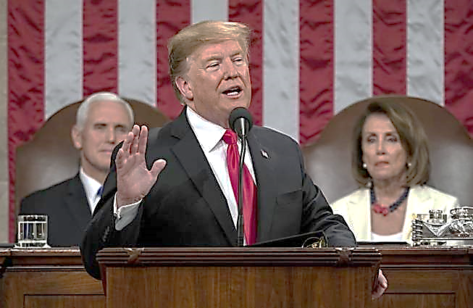
As I type this article, the State Of The Union speech is hours away. Our country has adopted an annual tradition for the President of the United States to stand before a joint session of congress (the Senate and House of Representatives) to report on the state of our nation. In my lifetime, I can’t recall a President who ever said, “The state of our nation is in big trouble!” It’s now more of ceremonial show that’s entrenched in “party politics” and my guess, the State Of The Union address will basically flow as it has over the last few decades.
You may be thinking, “Ken, this is supposed to be article about spiritual things!” and you would be right. Spiritual or Biblical instruction is my focus and yet, the events I witness in the world often encourages me to make some practical application from Biblical truths!
As I thought about the State Of The Union being addressed, it prompted me to think about the state of one’s “spiritual” union. Thankfully, there is still an overwhelming number of Americans who claim to be “believers” and yes, “believers in Jesus” and for that, I’m grateful! And yet, that question is quite probative: what about “the state of the union” that you personally claim to have with Jesus? Whether we properly diagnose America’s political State Of The Union” isn’t nearly as vital as a personal examination to our “state of the union” that exists between ourselves and Jesus Christ! (continued on the back)

