Shine Your Shoes
Mike Davis – Mike’s Musings
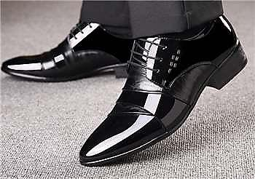
Shine your shoes and you’ll wear a smile.
Shine your shoes and you’ll be in style.
Sun shines east, sun shines west,
And Griffin Polish shines the best!

Some folks ain’t particular
‘Bout the way they look about their feet.
But if they wore shoes upon their head,
You can bet they’d look so neat!

So shine your shoes and you’ll wear a smile.
Shine your shoes and you’ll be in style.
Sun shines east, sun shines west,
And Griffin Polish shines the best!

I knew a man who every morning before he left for work, and especially every Lord’s Day morning before he left for services, would take out the bottle of Griffin’s Shoe Polish and shine his shoes. His reason was simple, “Most folks look down before they look you in the face. Put your best foot forward,” he said, “and they’ll have a good opinion of you and your conversation will move upward!” Well, not sure that always worked for him, but he sure didn’t like dirty shoes! (continued on the back)

