SENTENCE SERMONS
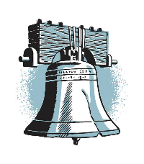
No man has the right to do wrong.
Shadows are proof of a shining sun.
A broken character doesn’t knit easily.
The road to heaven is never over-crowded.
When we mistreat people, we mistreat God.
To know what is right & not do it is cowardly.
He who is a Christian in little things is not little.
A pint of practicing is worth a barrel of preaching.
Faith “builds a bridge” from this world into the next.
We should first show others how to live, & then tell them.
A genuine Christian is a true “gentleman” or “gentlewoman.”
When some folks run into a telephone pole, they blame the pole.
In the scriptures, you can learn of a living Christ for a dying world.
Hardship is a real test of friendship with others ---- including Christ.
Alcohol takes the brakes off every passion -- it cripples our self-control.
If you trim yourself to suit everybody, you will soon whittle yourself away.
We are known by the company we keep and by the company we do not keep.
If there is true righteousness in the heart, there will be beauty in the character.

