Presidents’ Day
Kenneth D. Sils

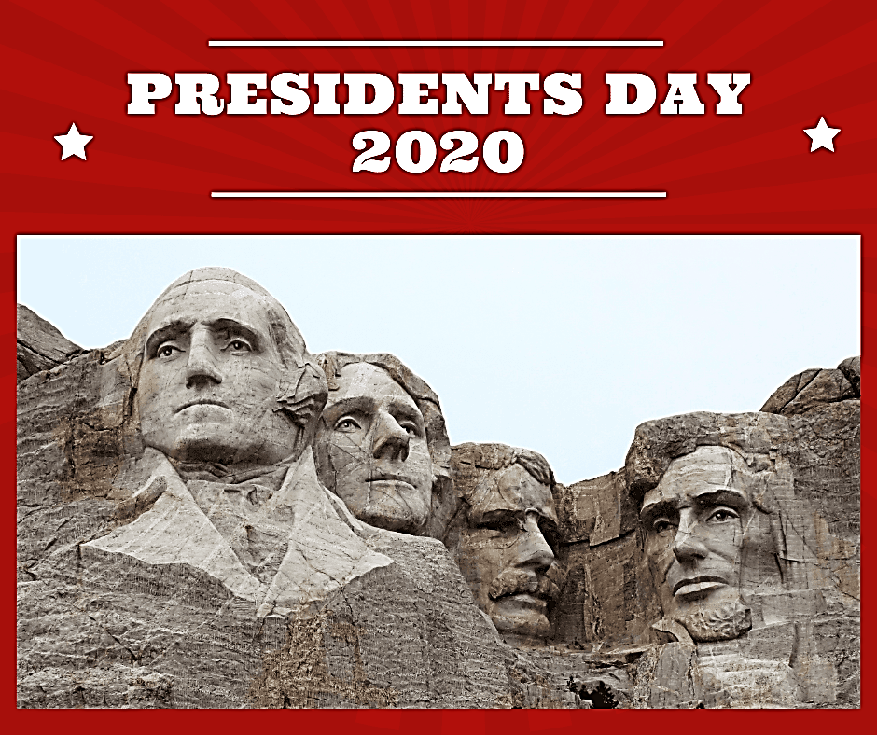

Did you know? Do you care? I’d say most really don’t care, other than the possibility of getting a day off of work or for the fact that we can’t go the bank or the Post Office. I remember when I was young, America used to celebrate Washington and Lincoln’s birthday individually and now, President’s Day is a merger of all “presidential” birthdays into one day for America to collectively observe and respect.
It is good for us, as Christians, to be reminded of our need to respect those who lead us or have authority over us. Peter told is in 1 Peter 2:17, “Honor all people. Love the brotherhood. Fear God. Honor the King." Why impress these truths in our heart? Because we have a greater king – King Jesus of Nazareth, our Savior, Redeemer, Lord and Judge! In a society which shamelessly taunts authority, we respect the powers that be, especially the greatest power of all: Jesus! Luke castigated false brethren, referring to them in Jude 8 with, “ … these dreamers defile the flesh, reject authority and speak evil of dignitaries.” Jude went on to say that these are sensual persons in vs. 19!
Christians, let’s be careful. Be respectful of community, national dignitaries and spiritual dignitaries. Your children, neighbors, local church and Jesus take notice if we project spiteful and hateful words against authorities. Don’t be one of those!

