Peter And Paul Preached The Same Gospel
Kenneth D. Sils

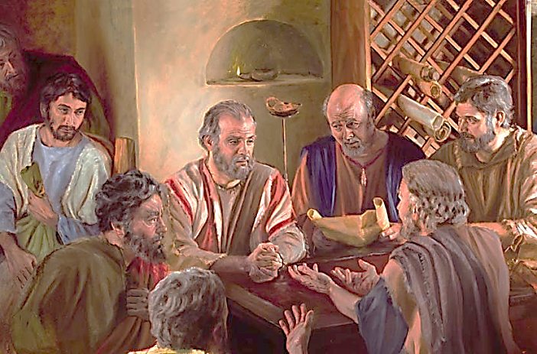

“I marvel that you are turning away so soon from Him who called you in the grace of Christ, to a different gospel, which is not another, but there are some who trouble you and want to pervert the gospel of Christ. But even if we, or an angel from heaven, preach another other gospel to you that what we have preached to you, let him be accursed.” (Galatians 1:6-8)

There is a segment of the denominational “grace” only movement that teaches that two apostles of Jesus were preaching “differing” gospels. They insist that Peter was preaching a “gospel of works” to the Jews and Paul was preaching a “gospel of grace” to the Gentiles. It is true that Paul was primarily sent to “Gentile” people while the evidence is fairly solid that Peter stayed primarily among those of Jewish descent; yet, that is where the difference ends. The gospel both men preached was identical! If that were not the case, Paul just called Peter a “cursed” man! Both men spoke by inspiration and both preached THE GOSPEL of Christ, the one and only gospel that Jesus commanded both men to preach. (continued on the back)

