Paul Now Preaches… THE FAITH
Kenneth D. Sils
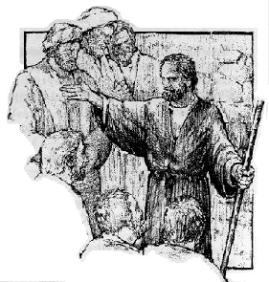
A major theme in the book of Galatians was Paul’s insistence on submission to the faith. He reminded brethren that his life dramatically changed upon conversion as he left “the traditions of my fathers, Galatians 1:14”, being Judaism. These Christians knew this truth as he taught in Galatians 1:23, “But they were hearing only, ‘He who persecuted us now preaches THE FAITH which he once tried to destroy.” Paul was now preaching THE FAITH… and they all glorified God!
What is Paul actually teaching? His preaching was not just about “faith” and it wasn’t just about “the death, burial and resurrection of Jesus”. It was in reference to all the glad tidings of man’s salvation as taught by Jesus and was dramatically different from his former days of clinging to: The Law of Moses, David & the Prophets.
Paul shared similar sentiments with the Romans as he expressed his desire to see them, stating in Romans 1:15, “… I am ready to preach the gospel to you who are in Rome also.” His preaching of THE FAITH in Galatia was the same concept as His preaching of THE GOSPEL to Rome. When one preaches THE FAITH, they are preaching the gospel of Jesus or simply put: the New Testament Scriptures!
Paul was a minister to THE FAITH. He told the Corinthians that fact in 2 Corinthians 3:6,”who made us sufficient as ministers of THE NEW COVENANT, not of the letter, but of the Spirit, for the letter kills, but the Spirit gives life.” Putting it all together, Paul preached: the Faith, the Gospel, the New Covenant or the instructions of Jesus. As Christians, we cling to THE FAITH -- it is the substance of our belief system, being members of the church of Christ!

