Parents Who Are Christians
Irvin Himmel – Poudre Valley e-bulletin
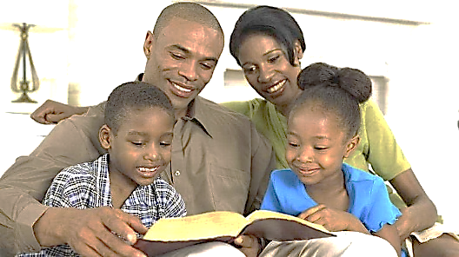
It is obvious that parents have an obligation to feed, clothe, love, protect and care for their offspring. A newborn human is about as helpless as any creature could be. Parents who are Christians have responsibilities which extend far beyond temporal provisions. There is an area of spiritual care, training, growth and development that demands special attention.
Parents who are Christians have an obligation to set a good example before their children. That includes a godly home life: no drugs, no tobacco, no strong drink, no profanity and no fussing and fighting. A good example means godly living in the home, on the job, while on vacation, during recreational activities and in all other situations. A good example includes regular attendance at Bible classes and church services. It also includes honesty, fairness, willingness to admit wrong and readiness to forgive.
Parents who are Christians have the responsibility of disciplining their offspring. Mischievous acts that may be dismissed as “cute” in the little ones can be quite annoying to others. Those “cute” little capers, if unchecked, can establish a pattern that turns into a nightmare by the time the child is a teenager. Discipline must start early. “Train up a child in the way he should go: and when he is old, he will not depart from it” (Proverbs 22:6).
Parents who are Christians should teach their children right priorities. Which comes first, your personal interests or the Lord’s work? Which is more important, a child’s solving a math problem or preparing a Bible lesson? The principle taught in Matthew 6:33 is learned quickly by a child who sees that basic truth demonstrated by his mother and father. Your child needs your help in establishing the correct sense of values.
Parents who are Christians are responsible for bringing up their children to be Christians. Put your child in the tiny tots’ class on Sunday morning and teach him to sit still during worship. If you do not train him, who will? Tell him some of the great stories in the Bible. Those historical narratives about Noah, Abraham, Daniel, Moses and others will do him more good than nursery rhymes and fairy tales. Drill him in Bible facts. Make him conscious that there is a wealth of material in the Bible. Teach him about God and Jesus Christ. Some fathers leave the spiritual training to the mothers. But the Bible says, “And, ye fathers, provoke not your children to wrath: but bring them up in the nurture and admonition of the Lord” (Ephesians 6:4). Daddy cannot shift his responsibility over to mother. The spiritual training of a child calls for the best efforts of both parents.
Christians who are parents have much for which to be thankful. Children are “an heritage of the Lord” (Psalms 127:3). But the responsibilities of parenthood are serious. In today’s wicked world, it is not easy to bring up children in the nurture of the Lord. However, it can be done.

