Once You Admit It, Will You Stop It?
Jarrod Jacobs – Poudre Valley e-bulletin
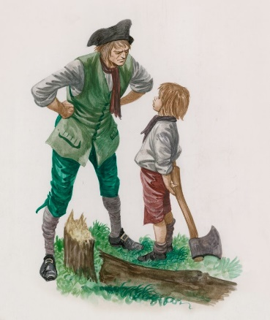
There was a cartoon several years ago in the Saturday Review of Literature in which little George Washington was standing with an axe in his hand. Before him lying on the ground is the famous cherry tree. He has already made his admission that he did it -- after all, he “cannot tell a lie.” Also pictured is his father, who is exasperated, and says, “All right, so you admit it! You always admit it! The question is, when are you going to stop doing it?”
The story above is an amusing one, but it makes a good point. Once we come to the point that we admit that we have committed a certain sin or sins, will we stop it? This question deserves our attention. Perhaps you know (as I do) of one who readily admits that he is a sinner, and in need of salvation. At the same time, this person will not take that next step, which is repent of those sins and live right by obeying the Gospel (Mark 16:16; Acts 2:38). How many people do we know who will admit (while they are smoking a cigarette, drinking their alcohol, etc.) that they are in error, and “it is a nasty habit,” but refuse to do anything about their sin? Many have said that one of the most difficult aspects of any problem is admitting that you have one. It seems like some people have “conquered” the fear of admitting their problem but will do nothing beyond that. How can continuing in a sin one recognizes and admits is sin, be beneficial to anyone?
In reading the Bible, we learn that it is a book that not only demands that men admit they are sinners in God’s sight, but also demands that men do something about that sin! In Old Testament days, Solomon said, “Whoever conceals his transgression will not prosper, but he who confesses and forsakes them will obtain mercy” (Proverbs 28:13). Notice please that God expected the man to confess AND forsake the sin in order to have mercy. It is not enough to merely confess and go on living in a particular sin! In New Testament days, Christ said, “Unless you repent, you will all likewise perish” (Luke 13:3). What does “repentance” mean? It means turning away from the way you used to live and living in accordance with Christ’s will! An example of repentance is found in the book of Matthew. Christ spoke a parable concerning two sons who were told by their father to go work in the vineyard. One boy said he would go but did not. The other refused, but later “repented and went” (Matthew 21:29). This boy not only had to admit that he was in the wrong for disobeying his father, but also had to do what was right! Read Luke 15:11-21 and see another son who was in the same position. In the word “repentance,” we see one not only recognizing he is guilty of sin, but also takes steps to stop it!
When Paul wrote the second epistle to the Corinthians, he told them that he knew what he wrote in the first letter would make them sorry, but he rejoiced because that godly sorrow led them to repentance (2 Corinthians 7:9-10). Notice that when you sorrow over an act that you know is wrong, you still have not done what is right! When one learns that he has sinned in the sight of God, he must not only admit that he is in sin, not only be sorry about the sin, but also turn from that sin! Only then can one think about being in a right relationship with God.
Dear friend, examine your life. Are there things you are doing which are in contradiction to the will of God? In what areas of your life are you guilty of sin? In those cases, not only must you face up to the fact that you are guilty, but then also take the necessary steps to get out of that sin. If you’re outside of Christ, then waste no time in repenting of your sins, confessing Christ as the Son of God and being baptized for the remission of sins (Acts 2:36-38, 8:36-38; Mark 16:16). If you’ve done those things already, but have been caught up in various sins, then turn from your error in repentance, confess those things and pray for God’s forgiveness (Acts 8:22; 1 John 1:9). It is not enough to admit you have a problem, you must cease in that and do what is right!

