O For A Faith That Will Not Shrink
Kenneth D. Sils

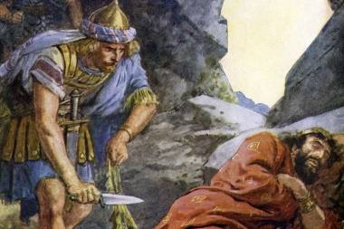

“O for a faith that will not shrink, tho’ pressed by every foe, that will not tremble on the brink of any earthly woe.” VS. 1 – Songs Of The Church

Wasn’t that an enjoyable Gospel Meeting we just had the privilege of participating in last week! Brigham Eubanks proclaimed some really great Bible lessons from the life of King David of Israel. The sweet Psalmist of Israel (2 Samuel 23:1) was a complex man, but we should not doubt the depth of his faith. David was personally named in the “Hebrew hall of faith, Hebrews 11:32”, but he also may have been one under consideration from the 37th and 38th verses describing those who, “wondered about in dens and caves of the earth, in whom the world is not worthy.”
A principle that Brigham brought out, more than once, was David’s steadfast allegiance in respecting the “Anointed” of God, despite being hounded like an animal. God selected Saul, son of Kish, to be the “anointed” king of Israel and despite God stripping that mantle from Saul and awarding it to David, he never let that move him to strike God’s first chosen “Anointed”. He had opportunity to kill him twice as Saul chased him around the wilderness, but David was determined to merely run and not be the cause of death to God’s first anointed King. I don’t know if I would have been able to bear up like that under persecution, but David did! Men and women of an “unshrinkable” faith possessed this gracious control of their spirit all the time.
The lesson for us is vital. It’s the type of faith which moves us to “turn the other cheek” when our enemy strikes us on the right cheek for our faith (Matthew 5:39). It’s the type of faith that one has when someone takes your tunic (or possession), and then you turn around and allow them to have another possession of greater value (Matthew 5:40). It’s the type of faith that is willing to bow before God, moved to ask Jesus in the midst of being persecuted nigh on to death, “Lord, do not charge them with this sin” (Acts 7:60), as you take your last breath from the Pagans beatings! This is the faith that holds up, that will not give up, nor give in. This is the faith that will get us to heaven! O for a faith that will not shrink! Let’s have a faith like that!

