Not A Hoof Left Behind
Robert Turner / Auburn Beacon
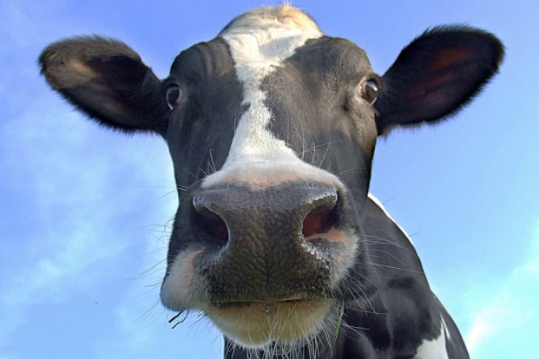
Exodus 7-12 records the efforts of God through Moses to persuade the Pharaoh of Egypt to release the children of Israel from bondage. As that bondage is often used to typify sin and Satan's hold on us, a better understanding of that ancient struggle could assist us today.
Pharaoh’s heart was stubborn, and the plagues of blood, frogs and lice did not move him, but when the flies came Pharaoh offered his first compromise. "Go ye, sacrifice to your god in the land” — do it here, no need to leave this land. When Moses refused such a suicidal attempt, Pharaoh offered his second compromise. "Go, only ye shall not go very far away: entreat for me". God removed the plague of flies, only to have Pharaoh harden his heart and refuse to let the people go. So, the cattle murrain, boils and hail came and the threat of locusts. Then came the third effort at compromise. "Go now ye that are men," leaving your women, children and the flocks behind. Neither Pharaoh nor Satan let go without a struggle, but Moses stood firm, so the locusts came; and after that, the darkness. Now Pharaoh tries one more compromise. "Go ye, serve Jehovah; only let your flocks and your herds be stayed." Take all to serve God, except your material possessions. Perhaps he knew their hearts would remain with the possessions — or perhaps he sought to deprive them of that which they would need to successfully carry out their new venture. Whatever: we are doomed to failure if we think we can serve God acceptably while leaving anything we control in Satan's hands.
But Moses accepted no compromise. "… NOT A HOOF SHALL BE LEFT BEHIND…” Exodus 10:26.
We must live in the world, but our citizenship is elsewhere. In making the transfer of allegiance, when we determine to give up the world and give ourselves to the Lord, we should then have also determined that, "… not a hoof shall be left behind." We should know that Satan will do all possible to convince us that we can serve God "in Egypt" or ''just a little way out" or compromising for the sake of family or possessions. It won't work that way! Give Satan a hoof, and he will take leg, loin, chuck roast and all.

