N.E.O.W.I.S.E.
Kenneth D. Sils

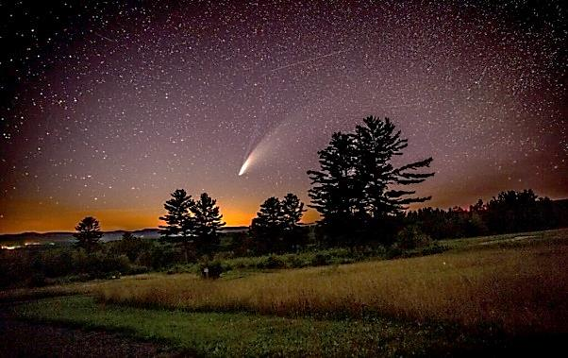

NEOWISE… discovered on March 27, 2020 by NASA’s “Near-Earth-Object-Widefield-Infared-Survey-Explorer” mission from the spacecraft originally named, Wide-Field Infared Survey Explorer (WISE). OK, what is NEOWISE? It’s a comet that is currently visible in the NW sky, just below the Big Dipper, visible after sunset. According to NASA, we’ve got through Wednesday night to see it fairly easy if the skies are clear and especially on Wednesday as NEOWISE is “climbing” in the sky within the inner solar system as it leaves us. Try using some binoculars!
What is the point of this article? There is something about a name. More often than not, names for children in the Bible have special meanings from the parent’s perspective. The other day, Sandra was wondering how many baby girls are going to be named “Rona” in 2020? Those poor girls! Now, not every name means something, but many still do. My middle name (which I do not freely share, by the way) comes from one of my uncles… don’t think ill of him, uncle Deo was a nice fellow!
Our name? Christian (Acts 11:26, 26:28; 1 Peter 4:16)! And that has deep, vital and amazing significance! It says to everyone who is paying attention: we trust Jesus having gone through the New Testament process of being born again. It means we are giving a conscience effort to be: like-Christ! We are trying to live as Jesus instructed, so we can die in Christ Jesus and be with God forever in heaven. It means we are resisting sinful activities, publicly worshiping God on a consistent, weekly basis and looking for daily opportunities to teach our community the gospel.
The name Christian… there’s nothing fancy about it, but it takes a life’s effort to adorn “Christ” before a lost and dying world. Think about this name: Christian!

