What “DAY” Was Last Wednesday?
Kenneth D. Sils
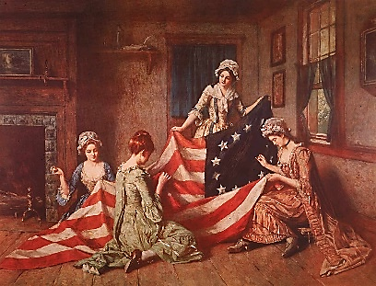
If you research the web, you’ll see that every day now has multiple declarations for being some type of special day. But nationally, our country celebrated National Flag Day.
Quoted from Betsy Ross house, “On June 14, 1777, less than one year after Betsy Ross had received the order from General Washington to make the first flag, the 2nd Continental Congress passed a flag resolution stating: ‘Resolved, That the flag of the United States be thirteen stripes, alternate red and white; that the union be thirteen stars, white in a blue field, representing a new Constellation.’ The first national observance of Flag Day was on June 14, 1877; 100 years after the flag resolution was adopted by the Continental Congress. In 1890, public school officials began to encourage commemorative activities on June 14th. Finally, in 1949, the congress proclaimed June 14th as Flag Day.”
There are a few denominations which protest and condemn others for celebrating national holidays, thinking the Bible opposes such individual secular nationality. Paul said in Acts 22:25, “Is it lawful for you to scourge a man who is a Roman, and uncondemned?” If Paul was allowed by God to refer to himself as a Roman, surely each of us are allowed a similar privilege to be Americans. Romans 13:1 states, “Let every soul be subject to the governing authorities.” Verse 7 adds, “Render therefore to all their due: taxes to whom taxes are due, customs to whom customs, fear to whom fear, honor to whom honor.”
Our flag was designed to symbolize who are nation represents. Fifty stars in a unified setting. Fifty separate states, united by the principles of our Constitution. A republic of states, governed by a standard law set in motion by our founding fathers over 245 years. In my humble opinion, this configuration has given the world the strongest nation ever known.
Did you know that the church of Christ is very much like this? 1 Corinthians 12:27 says, “Now, you are the body of Christ and members individually.” The church of Christ is comprised of members, all united together by the head of the church, Jesus, through His standard: the Gospel! The New Covenant is the standardized “constitution” for all members of the church of Christ. Christians honor the words of Jesus as the flagship of our faith.

