Mailing It In
Kenneth D. Sils

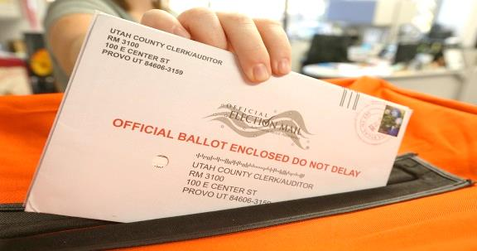

There is a considerable amount of discussion going on right now about the upcoming election for President. Because of the Coronavirus, many politicians are attempting to convince us that the time-honored Election Day principle of “showing up at the polls” voting should be scrapped in favor of “mail-in” voting. I have definite opinions about a national “mail-in” voting plan to elect our President, but I’ll reserve all of my objections universal mail in voting for a private conversation. After all, this is a bulletin article!
Spiritually speaking brethren, we can’t afford to be “mailing it in”! What do I mean by “mailing it in”? Wiktionary (what a great day we live in) defined the current phrase “mailing it in” as: to deliver a performance without commitment or effort, with lackluster results. This is the mantra of the lives of millions of people in our country today – no drive, no passion, no “get up and go” in their hearts! Many in our country are just “drifting” through life, being driven by the winds of mediocrity that come a knockin’ at their doors.
Jesus does not want us to live like this! We are people of purpose, resolve and fortitude. A Christian recognizes that he/she is on a journey through a “barren wilderness” called this life, in order to secure eternal joy, rest and peace in the Paradise that is to come! Paul told Titus that Jesus set out to, “redeem us from every lawless deed and purify for Himself His own special people, zealous for good works.” (Titus 2:14). We weren’t transformed into the glorious image of Jesus to just “mail it in” and coast to heaven! Nope!!! Some of us may have to give everything we have to give, just to make it to that “golden shore”, but it will be worth it.
Do you want your life to count? Just as it is with political voting, do what you can to make sure you’re identified, check-marked and received by the governing board – that would be Jesus! He doesn’t want us to “mail it in”. God expects more out of us and has given us time today to re-focus in our journey towards heaven. Don’t try to: mail it in!

