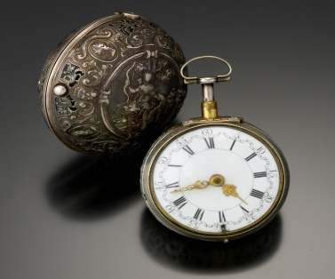
Before he died, a father said to his son, “Here is a watch that your grandfather gave me. It is almost 200 years old. Before I give it to you, go the jewelry store downtown. Tell them that I want to sell it, and see how much they offer you.”
The son went to the jewelry store, came back to his father and said, “They offered $150.00 because it’s so old.”
The father said, “Go to the pawn shop.”
The son went to the pawn shop, came back to his father and said, “The pawn shop only offered me $10.00 because it looked so worn.”
The father asked his son to go to the museum and show them the watch.
He went to the museum, came back, and said to his father, “The curator offered $500,000 for this very rare piece to be included in their precious antique collections.”
The father said, “I wanted to let you know that the right place values you in the right way. Don’t find yourself in the right place and get angry if you are not valued. Those that know your value are those who appreciate you, don’t stay in a place where nobody sees your value.” Know your worth. (copied)

