Jesus: Our Wonderful Counselor
Kenneth D. Sils

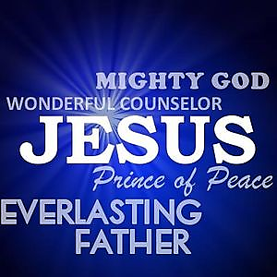
“For unto us a child is born, unto us a Son is given; and the government will be upon His shoulder. And His name will be called Wonderful, Counselor, Mighty God, Everlasting Father, Prince of Peace. Of the increase of His government and peace there will be no end, upon the throne of David and over His kingdom, to order it and establish it with judgment and justice from that time forward, even forever. The zeal of the Lord of hosts will perform this” (Isaiah 9:6-7). This is one of several prophetic utterances given by Isaiah, son of Amoz, written about 750 BC. By the time Jesus came to earth, this highly charged prophecy was embraced by the scholars of the nation of Israel to help them pinpoint their soon coming Messiah.
From the house of David, Jesus arose to fulfill every aspect of this grand prophecy. Documentation surrounding Jesus’ birth declares that He was no ordinary man, but that He left heaven and was transported into the womb of Mary to take on a body of flesh; thereby becoming both God and man. John begins his gospel stating in John 1:1, “In the beginning was the Word, and the Word was with God and the Word was God.” Jesus is God! He is God, the Son! As Jesus’ mission advanced, His close disciples came to realize this and worshipped Him, specifically noted from Matthew 14:33 after Jesus walked upon the surface of the water. (continued on the back)

