It’s Always Needed
Shane Williams / Poudre Valley e-bulletin

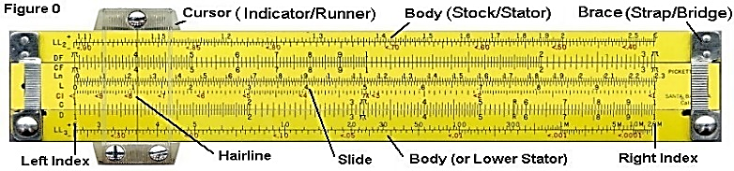

I heard a story of a man in the mid 1950's entering school to study engineering. A professor told the entering freshmen class to buy the best slide rule they could afford. The reason: "You will be dependent on it all your 'professional life.'" Well, of course, it wasn't too long before the slide rule was replaced by the calculator. We've seen those same sorts of things in recent years: 8 tracks, cassette tapes (almost), & even VHS tapes! (You can tell this was written when music CDs were popular… kds) Things that today we consider essential may quickly become obsolete. Tomorrow they may be discarded as antiques that cannot provide the help we need.

At least one thing from the past, however, will always be needed and never become obsolete. It is the Bible, God's Holy Word. No matter how much technological change and progress takes place, the Book will remain the one sure means for getting the right answers to the complicated questions: our origin, our purpose, our needs and our final destination. Make sure you keep your Bible around and use it! You'll always need it.
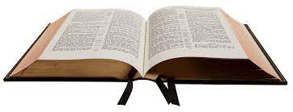
Psalm 119:105, "Your word is a lamp to my feet and a light to my path."
Psalm 18:30, "As for God, His way is perfect; The word of the Lord is proven; He is a shield to all who trust in Him."
Psalm 119:160, "The entirety of your word is truth, and every one of your righteous judgments endures forever."
1 Peter 1:23, "For you have been born again not of seed which is perishable but imperishable, that is, through the living and abiding word of God."

