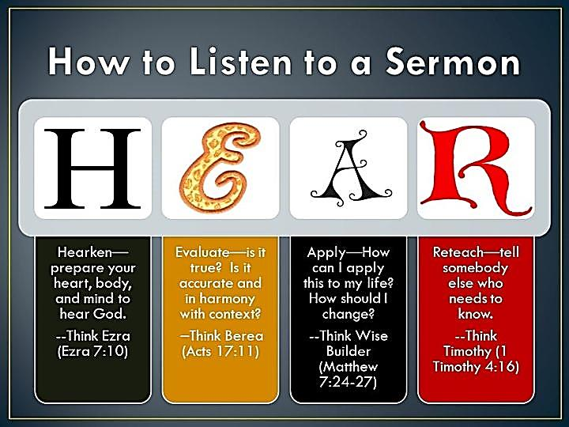
I copied this picture from a preacher’s Facebook’s feed to share it with you, along with a few comments. It persuades us not to be guilty of what Jesus called a “dullness of the heart” as the preaching of His message is occurring. Jesus told His disciples the reasoning behind His parables, “Therefore I speak to them in parables, because seeing they do not see and hearing they do not hear, nor do they understand.” (Matthew 13:14)
The Lord has allowed me to preach His gospel for over 37 years. Along the way, I’ve seen sermons “prick the hearts” of those I would have never guessed that those principles had an adverse bearing on them, while at the same time, individuals who really needed to hear that sermon wouldn’t allow one word to get beyond their stopped-up ear canals! The truth? “The word of God is living and sharper than any two edged sword, piercing even to the division of soul and spirit, and of joints and marrow, and is a discerner of the thoughts and the intents of the heart.” (Hebrews 4:12) God’s word is sharp, but only to those who will “let it in”!
I love going to Gospel meetings as it gives me an opportunity to hear a sermon. And there have been times I’ve left those meeting houses thinking, “Man, I’ve just got to do better!” Remember, when the preaching of the gospel of Christ is occurring: open your heart wide, take in all that spiritual food and allow Jesus’ truth move your attitudes, words and deeds towards the gates of heaven! When Jesus comes again, you’ll never regret receptively hearing the truth as, “Faith comes by hearing, and hearing by the word of God.” (Romans 10:17) -kds

