Honoring Men Above God
Frank Himmel
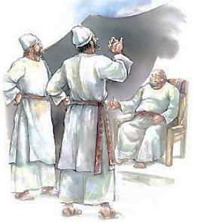 Hophni and Phinehas were despicable priests. Eli, their father, verbally rebuked them, but he did nothing further to restrain their abusive conduct. As a result, God brought judgment on Eli and his house. The Lord’s complaint to Eli was, “Why did you . . . honor your sons above Me?” (1 Samuel 2:29). Perhaps few would admit to honoring men above God, yet it is not all that unusual. Do we not do so:

- When we dismiss what the Bible says in favor of what some preacher told us? (2 Timothy 4:3-4)

- When we are more concerned with the world’s view of our appearance than God’s? (1 Timothy 2:9-10)

- When we marry someone whom God has said is not eligible to marry? (Matthew 19:9)

- When we put social activities ahead of worship? (Matthew 6:33)

- When due to peer pressure we compromise our morals? (1 Corinthians 15:33)

- When we refuse to preach on certain subjects for fear it might “turn off” some people? (Luke 9:26)

