Heed My Words
Kenneth D. Sils

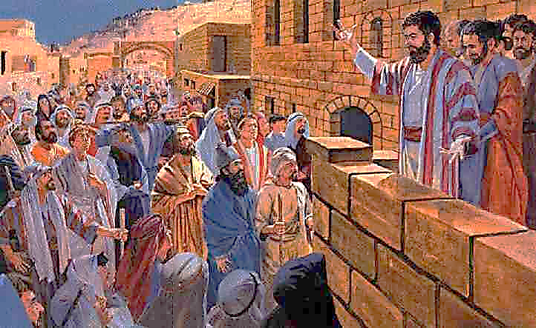

Now understand what I mean with the title of this lesson: this isn’t a personal type of command for you to “heed my words” because I’m a religious “somebody” – it’s a bulletin title extracted from Acts 2:14 from Peter, an apostle of Jesus Christ. Peter was empowered by Jesus to “bind and loose, Matthew 16:18” because he, along with all the apostles, had been granted the privilege to unlock the gate for the kingdom or church of Christ.
This was the first “salvo” in that “unlocking” mission as very devout Jews hurriedly gathered from curiosity due to the intense sound and the amazing display of power which now emanated from these 12 Galileans. They heard them miraculously speak in tongues, knowing they were “untrained men” who couldn’t possibly be doing what they were doing.
Our Gospel Meeting begins this Thursday evening, Lord willing. We’ve asked three very capable and well-studied evangelists from our local area to preach this week and I’ll be finishing our meeting next Sunday, Lord willing. The preachers will be focusing on five of the greatest sermons ever preached; sermons that “unlocked” the doors of the kingdom or church of Christ in the book known as, The Acts Of The Apostles! Ian Rice from Pensacola will examine this sermon that Peter gave to those devout Jews in Acts 2. Ben May from Andalusia will preach from the incredibly intense sermon given by Stephen in Acts 7. Brad Sullivan will expound on the amazing sermon Peter delivered to the family of Cornelius in Acts 10. We will conclude our meeting Sunday by considering two of the sermons Paul gave as he was being imprisoned for the message of Jesus!
I’ve heard it said: the best sermon is one that’s already preached. Well, if there’s any merit to that statement, this meeting will prove that! These sermons in Acts are “inspired” sermons. God preserved them for us to read, study and apply, whether it is the 1st or 21st century in America! Both Jew and Gentile need to hear Peter when he said: HEED MY WORDS! We need to hear them too as they continue to bring “good news” of salvation from their sins with the hope of heaven. Let’s be here... to hear... “these inspired words”!

