He Will Sit As A Refiner
Author unknown

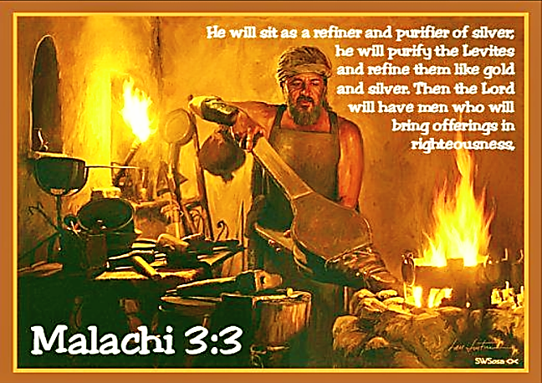

There was once a group of women studying the book of Malachi in the Old Testament. As they were studying chapter three, they came across verse three, which says, “He will sit as a refiner and purifier of silver.” This verse puzzled the women, and they wondered what this statement meant about the character and nature of God. One of the women offered to find out about the process of refining silver and get back to the group at their next Bible study.
That week this woman called up a silversmith and made an appointment to watch him at work. She didn’t mention anything about the reason for her interest beyond her curiosity about the process of refining silver. As she watched the silversmith, he held a piece of silver over the fire and let it heat up. He explained that in refining silver, one needed to hold the silver in the middle of the fire where the flames were hottest as to burn away all the impurities.
The woman thought about God holding us in such a hot spot – then she thought again about the verse, that he sits as a refiner and purifier of silver. She asked the silversmith if it was true that he had to sit there in front of the fire the whole time the silver was being refined. The man answered “Yes”, and explained that he not only had to sit there holding the silver, but he had to keep his eyes on the silver the entire time it was in the fire. If the silver was left even a moment too long in the flames, it would be damaged.
The woman was silent for a moment. Then she asked the silversmith, “How do you know when the silver is fully refined?”
He smiled at her and answered, “Oh, that’s easy. When I see my image in it.”
If today you are feeling the heat of this world’s fire, just remember that God the Father and His Son Jesus Christ have Their eyes on you.

