God’s Law Or Man’s
Mike Davis - Mike’s Musings, 12/2022

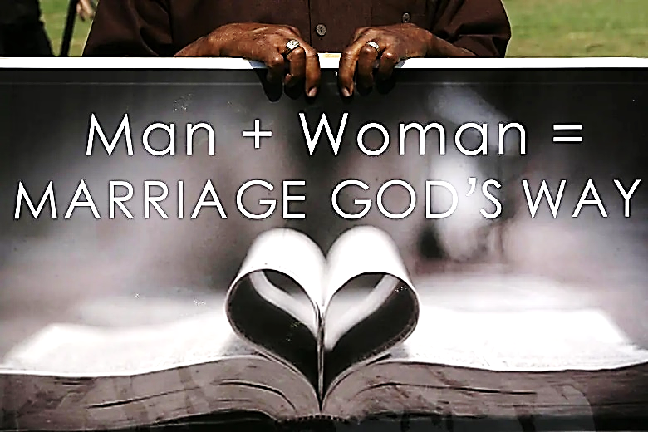

As a gospel preacher, I know well the dangers of speaking more of politics than the gospel of Jesus Christ. Nevertheless, our present times demand we of TRUTH speak up! If the gospel is hidden, it is hidden to the lost (2 Corinthians 4:3). Further, during the past few years, the evidence is clear that many of our political leaders are endeavoring with great vigor to ignore God’s Law altogether to further their desires of “inclusion” for all walks of life as “equal” when God’s law clearly distinguishes between GOOD and EVIL. Yes, if it were possible (which it is NOT, Matthew 24:35), many lawmakers would eliminate God’s law entirely, thinking as Israel once thought, and perished for the evil! (Isaiah 30:8-17).
This past week, President Biden signed into law The Respect for Marriage Act. Indicating his definition of marriage, Biden said, “Marriage is a simple proposition. Who do you love? And will you be loyal to that person you love?” Biden further said, “For most of our nation’s history, we denied ‘same-sex’ couples from these protections. [The law] failed to treat them with equal dignity and respect. And now, this law requires ‘same-sex’ marriage[s] must be recognized as legal in every state in the nation.” Mr. President, YOU ARE WRONG! (continued on the back)

