Give Me The B.I.B.L.E
Kenneth D. Sils

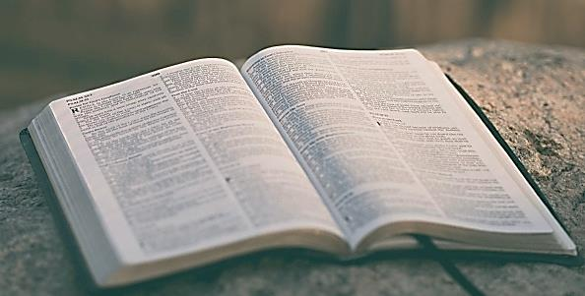

“Give me the Bible, holy message shining; Thy light shall guide me in the narrow way, precept and promise, law and love combining, till night shall vanish in eternal day.” #280 (Chorus), Psalms, Hymns & Spiritual Songs

B... BELIEVE all the teachings of the Bible. “All Scripture is given by inspiration of God and is profitable for doctrine, for reproof, for correction, for instruction in righteousness, that the man of God may be complete, thoroughly equipped for every good work.” 2 Timothy 3:16-17

I... INVESTIGATE all the teachings of the Bible. “The entrance of Your words gives light; it gives understanding to the simple.” Psalm 119:130

B... BUY all the teachings of the Bible. “Buy the truth, and do not sell it, also wisdom and instruction and understanding.” Proverbs 23:23

L... LOVE all the teachings of the Bible. “Oh, how I love your law! It is my meditation all the day.” Psalm 119:97

E... EAT all the teachings of the Bible. “Your words were found, and I ate them, and Your word was to me the joy and rejoicing of my heart; for I am called by Your name, O Lord God of hosts.” Jeremiah 15:16

