Give Me Liberty Or Give Me Death!
Kenneth D. Sils

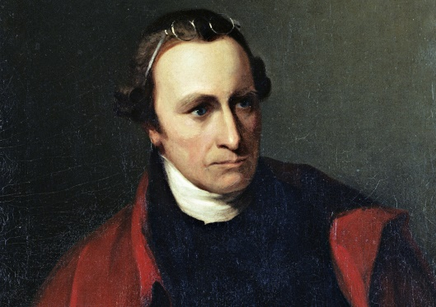
“Why stand we here idle? What is it that gentlemen wish? What would they have? Is life so dear, or peace so sweet, as to be purchased at the price of chains and slavery? Forbid it, Almighty God! I know not what course others may take; but as for me, give me liberty or give me death!” Patrick Henry – March 23, 1775

Today is the 4th of July! As fellow Americans, we may be thinking back to the origins of the country that God has granted us the privilege to live in. We are a blessed people with liberties and freedoms that are still unmatched among the world. Many of us are quite concerned that we may be losing these freedoms at an escalating rate. I surely don’t have many answers to such a question, but this one thing I know we can all do – pray! Pray... and stay strong in Jesus Christ!
That quote is still quite moving, isn’t it: GIVE ME LIBERTY OR GIVE ME DEATH! Mr. Henry knew that he was going to reap one of those two options. Friends, I have no idea if Mr. Henry knew this, but the same is true for all people spiritually! Remember Paul saying to the Romans this in Romans 6:23, “For the wages of sin is death, but the gift of God is eternal life in Christ Jesus our Lord!” By inspiration, Paul was saying... GIVE ME LIBERTY, not death!
God has graciously extended His merciful hand towards us, lifting us from the ash heap of death through the blood of Jesus Christ. Paul was pressing that point to the Christians in Rome, who were reminded that their being “baptized” into the death, burial and resurrection of Christ (Romans 6:3-7) FREED... yes, FREED them from their sins, making eternal life possible for them.
That same pattern is available for all people today. If you are willing to be born again (to be born of the water and Spirit, John 3:3-5), your soul shall be freed from the bondage of sin and you can start walking in Jesus Christ to life eternal! Spiritually, I share the sentiments of Patrick Henry, but I don’t have to eternally die. I’m alive in Christ Jesus. You can be spiritually “free” too!

