The Faithful Women of Galilee
Ben May / Guest Speaker In Our Meeting

“And when Jesus had cried out with a loud voice, He said, ‘Father, ‘into Your hands I commit My spirit.’ Having said this, He breathed His last. So when the centurion saw what had happened, he glorified God, saying, ‘Certainly this was a righteous Man!’ And the whole crowd who came together to that sight, seeing what had been done, beat their breasts, and returned. But all His acquaintances, and the women who followed Him from Galilee, stood at a distance, watching these things.” Luke 23:46-49

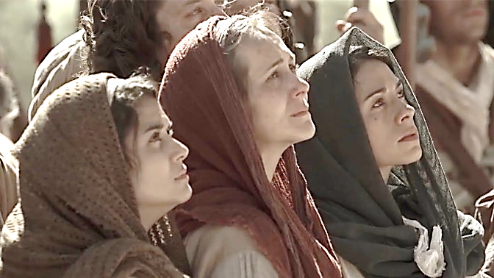

Who were these women from Galilee? The scriptures seem to make a special effort to distinguish them from the rest. Perhaps we can find the answer in Luke 8:1-3, “Now it came to pass, afterward, that He went through every city and village, preaching and bringing the glad tidings of the kingdom of God. And the twelve were with Him, and certain women who had been healed of evil spirits and infirmities – Mary called Magdalene, out of whom had come seven demons, and Joanna the wife of Chuza, Herod’s steward, and Susanna, and many others who provided for Him from their substance.” These women were evidently the same as those who watched at a safe distance the crucifixion and death of Jesus, their Savior. (continued on the back)

